

M.Sc. Computer Science and Engineering

Hypermedia Applications Project



Leoni Luca 10574709

Minotti Luca 10572239

Ratti Francesco 10640265

www.reply.com

Usability Report

23rd March 2021

Version 1.0

**Abstract**

The aim of this Usability Report is to describe the results of the usability assessment carried out on the Reply website. Specifically, the analysis is performed using first the inspection method and then the user testing method.

The first method involves expert evaluators examining the application interface and evaluating its compliance with recognized usability principles called heuristics. Specifically, the analysis is conducted with reference to the Nielsen and MILE heuristics.

The user testing method instead consists of the data collection and observation of how some representatives of real users interact with the system. Its goal is to discover the actual difficulties encountered by users when interacting with the website and to obtain systematic feedback on its effectiveness and use.

**Authors**

**Francesco Ratti**

*MSc Computer Science and Engineering*

[francesco2.ratti@mail.polimi.it](mailto:francesco2.ratti@mail.polimi.it)

+39 000000000



**Luca Minotti**

*MSc Computer Science and Engineering*

[luca2.minotti@mail.polimi.it](mailto:luca2.minotti@mail.polimi.it)

+39 3315228707



**Luca Leoni**

*MSc Computer Science and Engineering – EIT Digital Human Computer Interaction and Design*

[luca3.leoni@mail.polimi.it](mailto:luca3.leoni@mail.polimi.it)

+39 3484124137



**Contents**

1 Inspection 5

1.1 Inspection Design 5

1.1.1 Heuristics Definition 5

1.1.2 Metrics Definition 6

1.1.3 Evaluation Process Definition 7

1.2 Inspection Execution 7

A Inspection Annex 17

A.1 Individual Inspection 1 17

A.2 Individual Inspection 2 23

A.3 Individual Inspection 3 31

2 User Testing 39

2.1 User Testing Design 39

2.1.1 User Profile Definition 39

2.1.2 Usability Variables Definition 39

2.1.3 Tasks Definition 40

2.1.4 Pilot Test 41

2.1.5 Post Test Questionnaire 41

2.2 User Testing Execution 42

2.2.1 Execution 42

2.2.2 Data Analysis 42

3 Final Conclusions 47

3.1 Comments on the results 47

3.2 Suggestion for Improvements 47

B User Testing Annex 48

B.1 Information for Test Users 48

B.2 User Test 1 50

B.3 User Test 2 52

B.4 User Test 3 54

B.5 User Test 4 56

B.6 User Test 5 58

B.7 User Test 6 60

B.8 User Test 7 62

B.9 User Test 8 64

# 1 Inspection

Usability inspection is the generic name for a category of methods based on having expert evaluatorsanalytically examine UX-related aspects of an application. Typically, usability inspection is aimed at finding usability problems in a design, though some methods also address issues like the severity of the usability problems and the overall usability of an entire design. Here we focus on *Heuristic Evaluation*, an inspection method that involves evaluators examining the interface and judging its compliance with recognized usability principles (the "*heuristics"*).

## 1.1 Inspection Design

### 1.1.1 Heuristics Definition

This section precisely defines the heuristics used to conduct the inspection. Specifically, the analysis refers to the principles outlined by the *Nielsen* and *MILE* heuristics.

#### 1.1.1.1 Nielsen Heuristics

Jakob Nielsen’s heuristics are the most-used usability heuristics for user interface design. Released in 1994, they define the following principles:

* **Visibility of system status:** the design should always keep users informed about what is going on, through appropriate feedback within a reasonable amount of time.
* **Match between system and the real world:** the system should speak the users’ language, with words, phrases and concepts familiar to the user, rather than system-oriented terms. Follow real-world conventions, making information appear in a natural and logical order.
* **User control and freedom:** users often choose system functions by mistake and will need a clearly marked “emergency exit” to leave the unwanted state without having to go through an extended dialogue. Support undo and redo.
* **Consistency and standards:** users should not have to wonder whether different words, situations, or actions mean the same thing. Follow “platform” conventions.
* **Error prevention:** even better than good error messages is a careful design that prevents a problem from occurring in the first place. Either eliminate error-prone conditions or check for them and present users with a confirmation option before they commit to the action.
* **Recognition rather than recall:** minimize the user’s memory load by making objects, actions, and options visible. The user should not have to remember information from one part of the dialogue to another. Instructions for use of the system should be visible or easily retrievable whenever appropriate.
* **Flexibility and efficiency of use:** accelerators - unseen by the novice user - may often speed up the interaction for the expert user such that the system can cater to both inexperienced and experienced users. Allow users to tailor frequent actions.
* **Aesthetic and minimalist design:** dialogues should not contain information that is irrelevant or rarely needed. Every extra unit of information in a dialogue competes with the relevant units of information and diminishes their relative visibility.
* **Help users recognize, diagnose and recover from errors:** error messages should be expressed in plain language (no codes), precisely indicate the problem, and constructively suggest a solution.
* **Help and documentation:** even though it is better if the system can be used without documentation, it may be necessary to provide help and documentation. Any such information should be easy to search, focused on the user’s task, list concrete steps to be carried out, and not be too large.

#### 1.1.1.2 MILE Heuristics

MILE is a scenario-based inspection technique that includes a large number of heuristics. For the execution of the analysis, only the following subset is considered:

***Navigation heuristics***

* **Interaction consistency**: do pages of the same type have the same links and interaction capability?
* **Group navigation**: is it easy to navigate from and among groups of “items”? E.g., from the “list of items” of a group to its “members” (and the other way around); among different “groups”; among members of the same group (next/previous).
* **Structural Navigation**: is it easy to navigate among the “components” (parts) of a topic?
* **Semantic Navigation**: is it easy to navigate from a topic to a related one (in both directions)?
* **Landmarks**: are “landmarks” useful to reach the key parts of the web site?

***Content heuristics***

* **Information overload**: is the information in a page too much/too little?

***Presentation heuristics***

* **Text layout**: is the text readable? Is font size appropriate?
* **Interaction placeholders-semiotics**: are textual or visual labels of interactive elements “expressive”? i.e., do they reflect the meaning of the interaction and its effects?
* **Interaction placeholders-consistency**: are textual or visual labels of interactive elements consistent in terms of wording, icon, position, etc.?
* **Spatial allocation**: is the on-screen allocation of contents and visual elements appropriate for their relevance? Are “semantically related” elements close and “semantically distant” element far away?
* **Consistency of Page Structure**: do pages of the same type have the same layout (same visual properties of each component and similar organization and layout of the various elements)?

### 1.1.2 Metrics Definition

The metrics used for the inspection are defined as follows:

|  |  |
| --- | --- |
| **Metric** | **Description** |
| N/A | Not applicable. |
| 0 | The heuristic is NOT satisfied; severe violations have been detected. |
| 1 | The heuristic is partly satisfied, the website is structured adequately according to the heuristics, but they are implemented in the wrong way. |
| 2 | The heuristic is partly satisfied but it can be massively improved. |
| 3 | The heuristic is almost satisfied. There are many imperfections. |
| 4 | The heuristic is almost fully satisfied but there are some imperfections. |
| 5 | The heuristic is FULLY satisfied; no violation has been detected. |

### 1.1.3 Evaluation Process Definition

The inspection is carried out as specified in this section. First, each expert evaluator individually carries out an in-depth analysis of the website by referring to the previously defined heuristics and metrics. By doing this, a time of at least 15 minutes will be dedicated to each of the main sections. All the detailed reports of these analyses are given in the *Inspection Annex**.* The results are then discussed among all the inspectors to reach a shared agreement on comments and scores.

The usability evaluation is carried out on the entire website, with particular attention to the following pages and sections:

* *Homepage*
* *Topics Section*
* *Industries Section*
* *Careers Page (Join)*
* *About Page*
* *Investors Page*
* *Newsroom Page*
* *Personal Profile Page*
* *Search Page*

## 1.2 Inspection Execution

This section reports the results of the inspection process defined above with the precise details of any identified problem. In the following multiple explanatory screenshots of these criticalities are also provided.

|  |  |  |
| --- | --- | --- |
| **Heuristic Type** | **Heuristic** | **Overall Score** |
| Nielsen | Visibility of system status | 1 |

The breadcrumb is visible on some pages so that the user can know where he/she is. However, it is badly implemented. The problem is that the breadcrumb is not effective: in each section, it shows only the name of the current section and an ‘X’ icon, without giving further details about the top-level section (Screenshot 1). Furthermore, in certain pages the breadcrumb disappears completely, leaving the user with no information about the current state as can be seen from Screenshot 2.

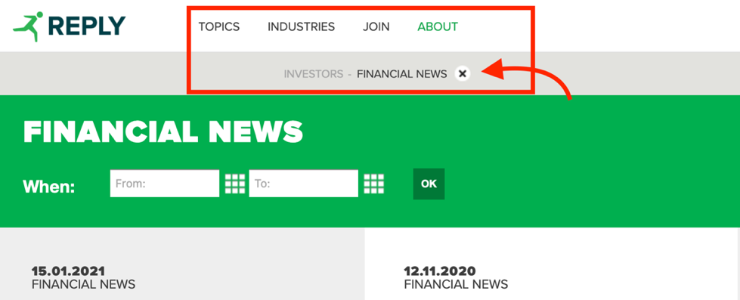

Screenshot 1: <https://www.reply.com/en/investors/news/>



Screenshot 2: <https://www.reply.com/cluster-reply/en/drive-value-with-windows10-and-sccm>

|  |  |  |
| --- | --- | --- |
| **Heuristic Type** | **Heuristic** | **Overall Score** |
| Nielsen | Match between system and the real world | 3 |

As highlighted in Screenshot 4 and Screenshot 5, the main problem with this heuristic is related to the partial translation of the website. Indeed, the navigation bar, the search bar and all the error messages are shown in English, regardless of the language chosen by the user.

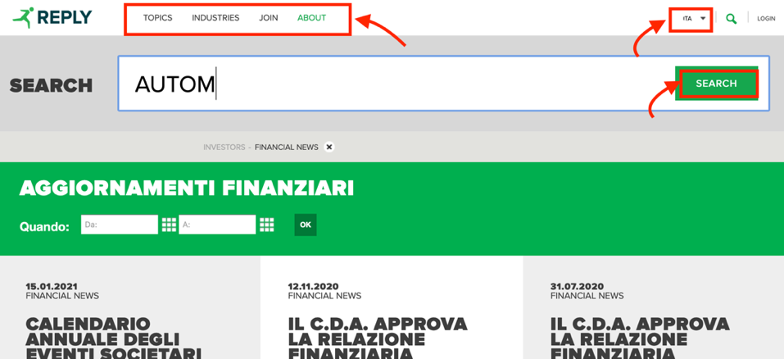

Screenshot 3: <https://www.reply.com/en/investors/news/>



Screenshot 4: <https://www.reply.com/en/filenotfound>

|  |  |  |
| --- | --- | --- |
| **Heuristic Type** | **Heuristic** | **Overall Score** |
| Nielsen | User control and freedom | 5 |

The heuristic is satisfied. Indeed, it is always possible to modify a previous choice without having to start over. For instance, when filtering the events by date, the user can edit the selected date range at any time, as shown in Screenshot 5. In addition, the user is freely able to navigate the website and leave the current page through the persistent header.

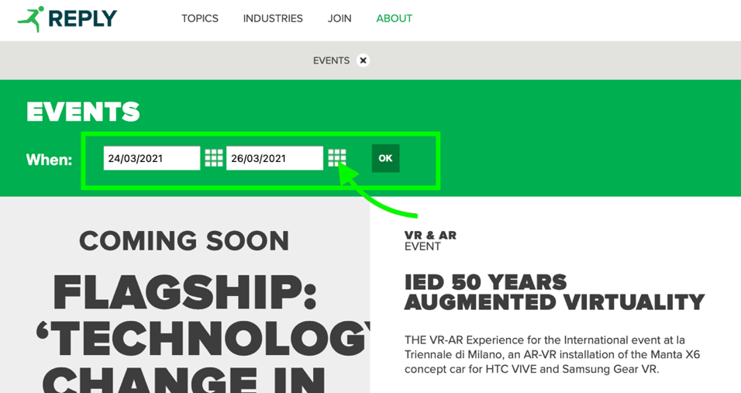

Screenshot 5: <https://www.reply.com/en/newsroom/events/>

|  |  |  |
| --- | --- | --- |
| **Heuristic Type** | **Heuristic** | **Overall Score** |
| Nielsen | Consistency and standards | 5 |

The basic standards are satisfied throughout the website. For example, as shown in Screenshot 6, the position of the login button and that of the search icon is the standard one. Furthermore, the +/- icons in the footer and the arrow in the drop-down menu have the typical meaning. Moreover, the website is consistent in terminology usage.

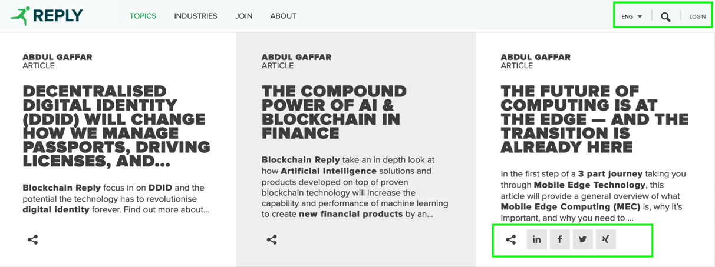

Screenshot 6: <https://www.reply.com/en/blockchain>

|  |  |  |
| --- | --- | --- |
| **Heuristic Type** | **Heuristic** | **Overall Score** |
| Nielsen | Error prevention | 3 |

The system has some weaknesses concerning this heuristic. For instance, as shown in Screenshot 8, when a new user goes through the registration process, he/she has no way of knowing the password security requirements until after submitting the form. On the other hand, the system requests confirmation to carry out some operations that the user may incorrectly select, such as the deletion of the account (Screenshot 7).

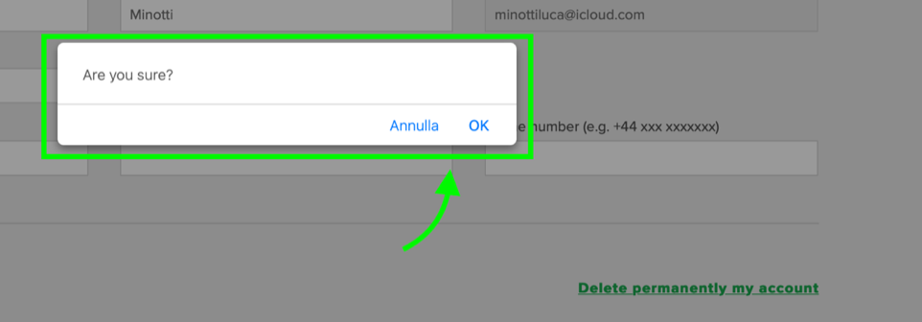

Screenshot 7: <https://www.reply.com/en/userprofile>

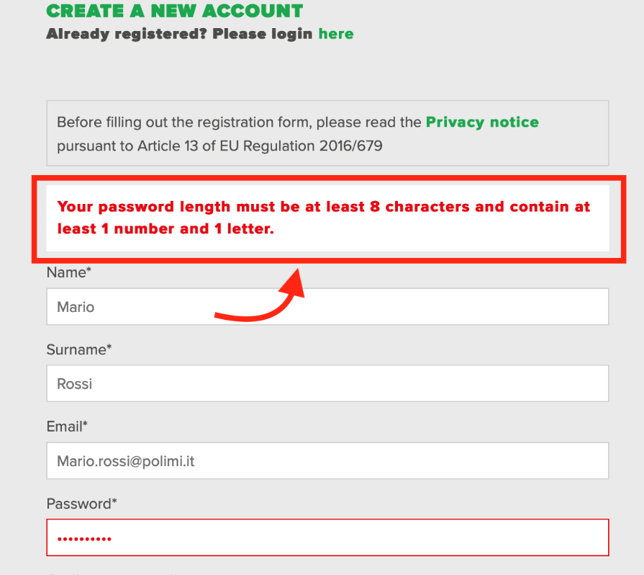

Screenshot 8: <https://www.reply.com/en/register>

|  |  |  |
| --- | --- | --- |
| **Heuristic Type** | **Heuristic** | **Overall Score** |
| Nielsen | Recognition rather than recall | 2 |

As highlighted in Screenshot 9, the system does not provide any suggestion when a user tries to search for something. Also, during the registration process, some fields could be implemented as a dropdown list instead of plain text input (e.g., Role field). Despite this, in the Webinar section, a very effective live filtering search box has been implemented (every time the user types a letter, the system checks and shows only the matching results).

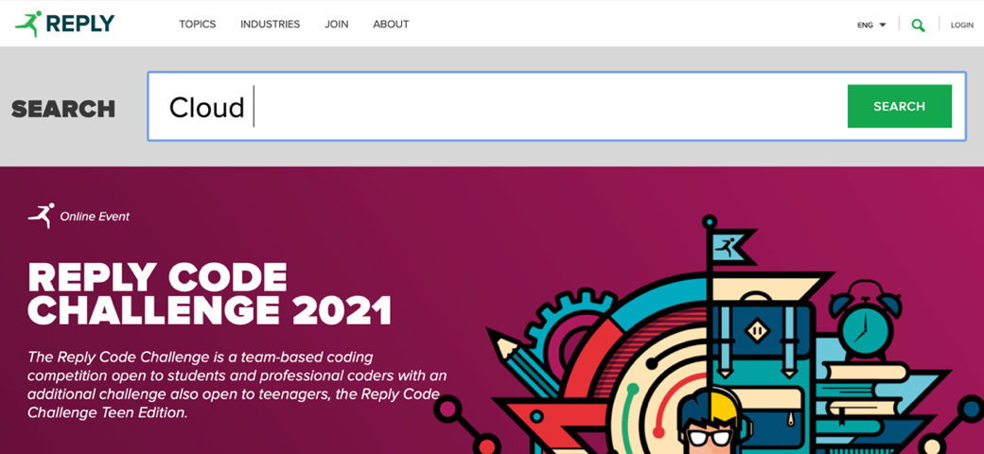

Screenshot 9: <https://www.reply.com/en>

|  |  |  |
| --- | --- | --- |
| **Heuristic Type** | **Heuristic** | **Overall Score** |
| Nielsen | Flexibility and efficiency of use | 3 |

The navigation through the “Topics” menu in the header is chaotic and inefficient, the topics are all listed without further categorization or grouping. In addition, there are also some problems with flexibility. For example, as shown in Screenshot 10, when looking for a webinar the search form does not allow you to select past dates. To view previous webinars, you need to visit a different section, which is counterintuitive.

On the other hand, some accelerators are well implemented on the website. For example, as highlighted in Screenshot 11, the system allows the insertion of dates both through the textboxes (novice user) and through the calendar icon (accelerator for expert user).

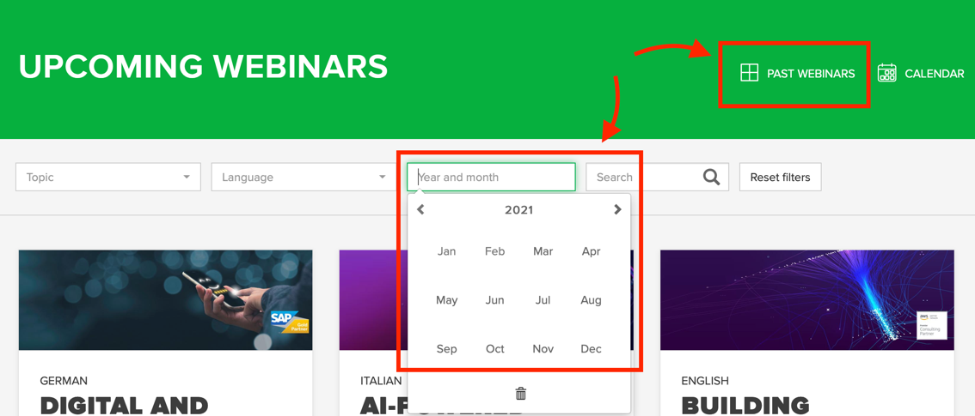

Screenshot 10: <https://webinars.reply.com>

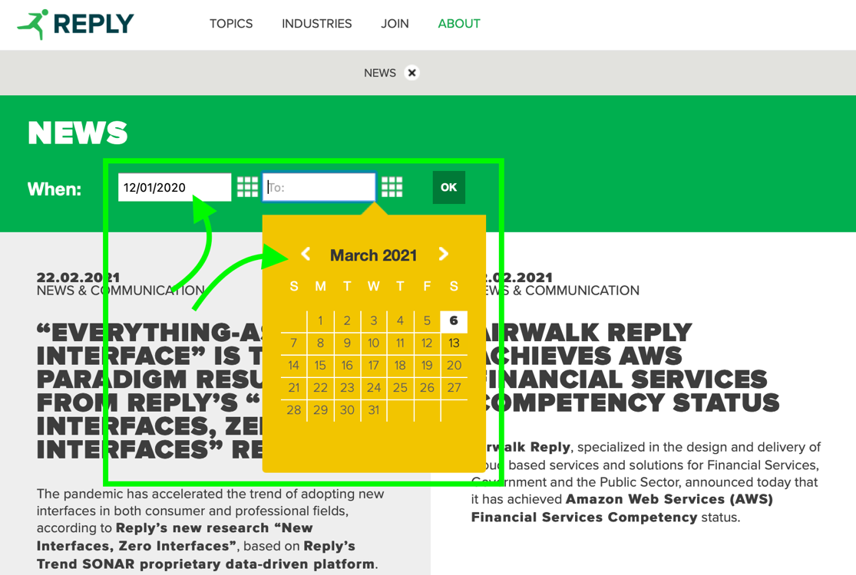

Screenshot 11: <https://www.reply.com/en/newsroom/news/>

|  |  |  |
| --- | --- | --- |
| **Heuristic Type** | **Heuristic** | **Overall Score** |
| Nielsen | Aesthetic and minimalist design | 2 |

The website is aesthetically good. Despite this, the style adopted does not match the minimalist one. For instance, the homepage acts as a showcase with too many articles with very long descriptions. Moreover, as shown in Screenshot 12, the pages of the website are often crowded with images and other graphic elements. Everything is too compacted, leading to an information explosion.

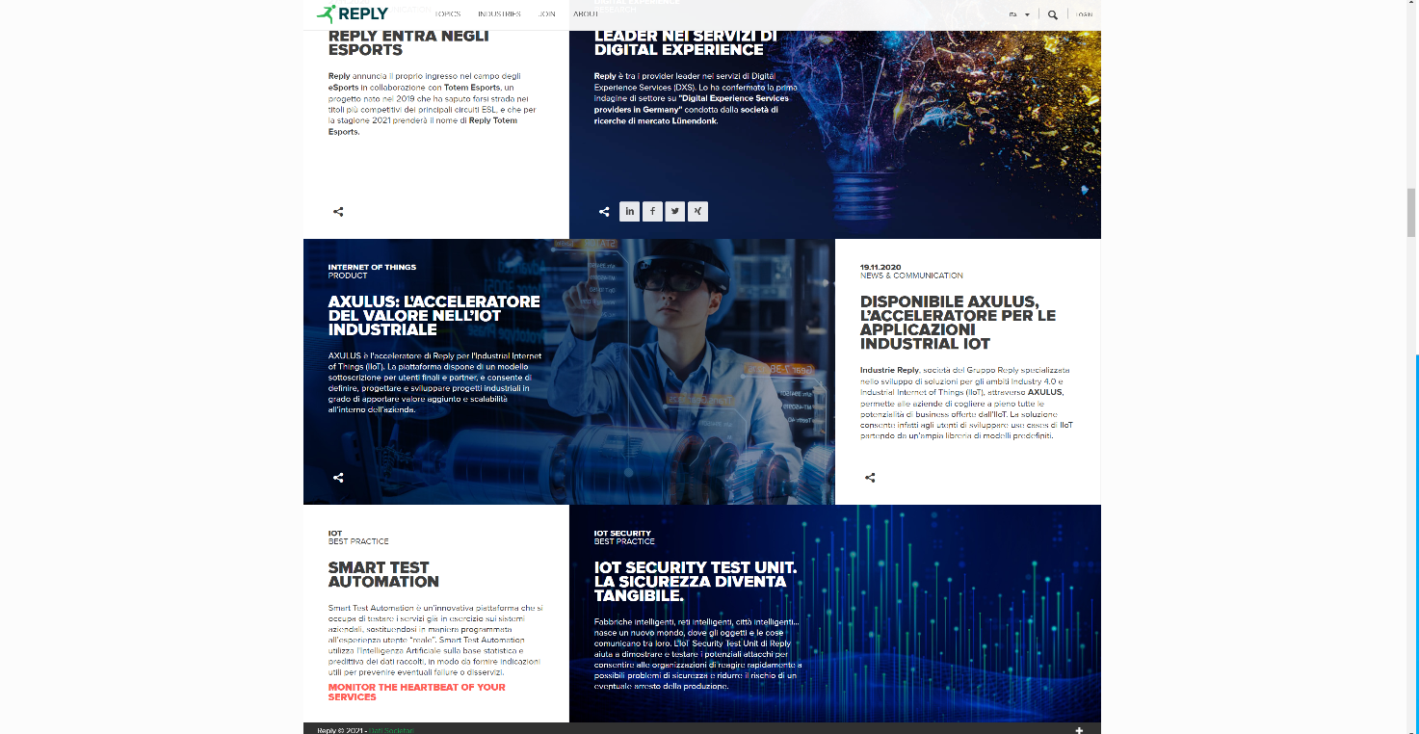

Screenshot 12: <https://www.reply.com/en/topics/internet-of-things/>

|  |  |  |
| --- | --- | --- |
| **Heuristic Type** | **Heuristic** | **Overall Score** |
| Nielsen | Help users recognize, diagnose and recover from errors | 1 |

This heuristic is not satisfied in several cases. During the login process, if a user writes the wrong email or password, the system notifies him/her with a generic error message (Screenshot 13). Moreover, some errors, such as the Page Not Found one, are accompanied by a short explanation message, while others simply show a code and give no indication of what went wrong (Screenshot 14, Screenshot 15).

Despite that, it is possible to recover from some erroneous situations. For instance, as shown in Screenshot 16, if a user uses the search box and commits a typo, the system is able to detect it, even if it does not show directly the correct answers.

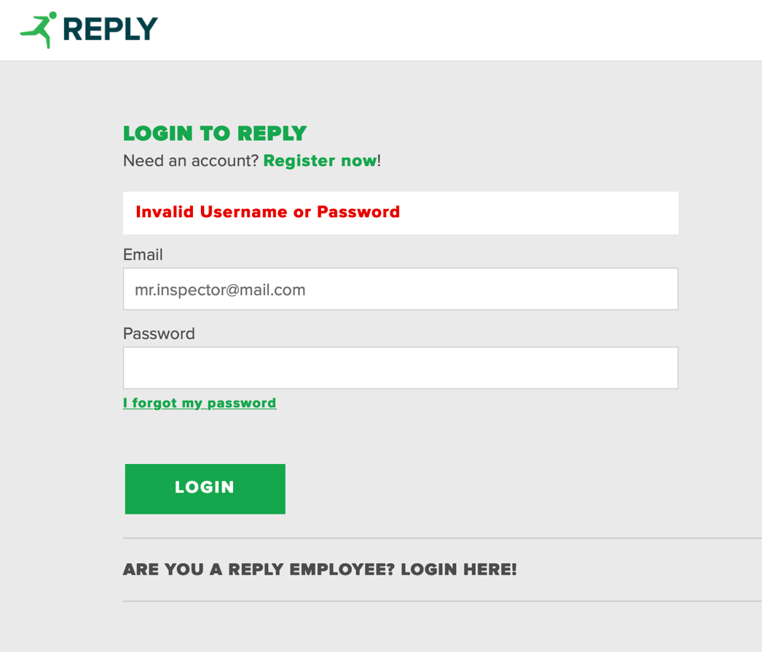

Screenshot 13: <https://www.reply.com/en>

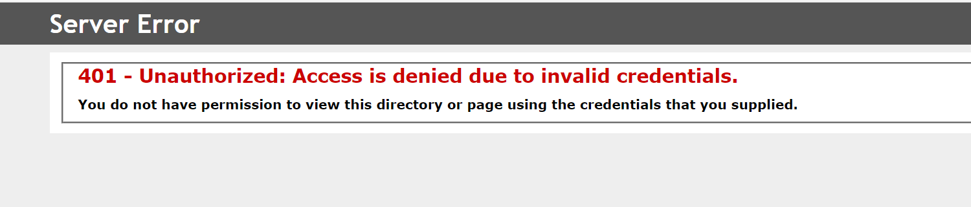

Screenshot 14: <https://www.reply.com/en>

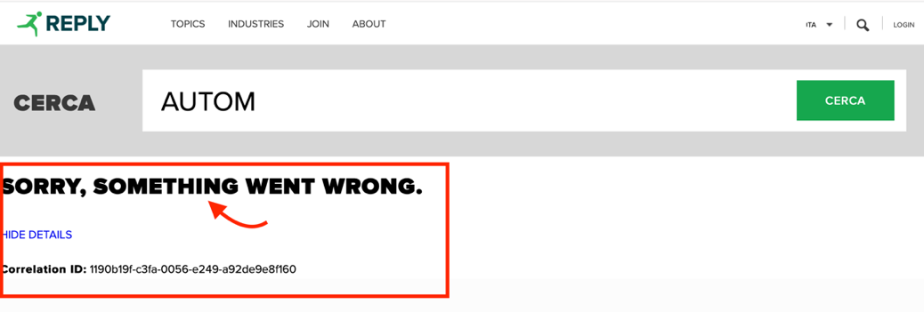

Screenshot 15: <https://www.reply.com/en>

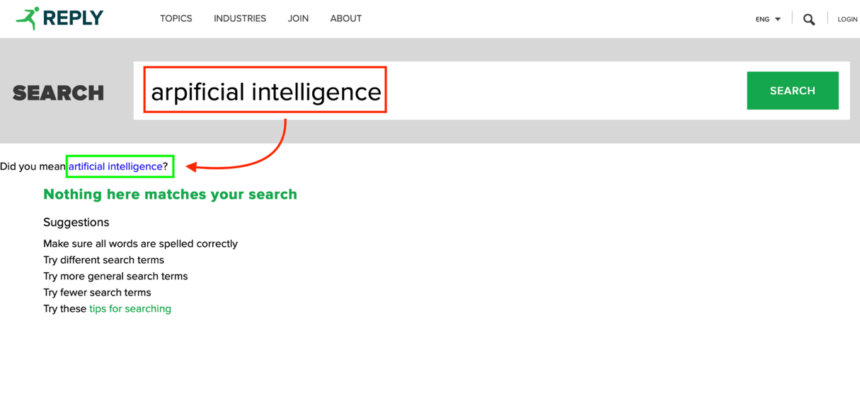

Screenshot 16: <https://www.reply.com/en>

|  |  |  |
| --- | --- | --- |
| **Heuristic Type** | **Heuristic** | **Overall Score** |
| Nielsen | Help and documentation | N/A |

This heuristic does not apply to the system under consideration.

|  |  |  |
| --- | --- | --- |
| **Heuristic Type** | **Heuristic** | **Overall Score** |
| MILE Navigation | Interaction consistency | 4 |

The heuristic is almost satisfied. However, some similar pages have not the same interaction capabilities. For example, as highlighted in Screenshot 17, some case study articles open as a pop-up, while others open as a new tab.

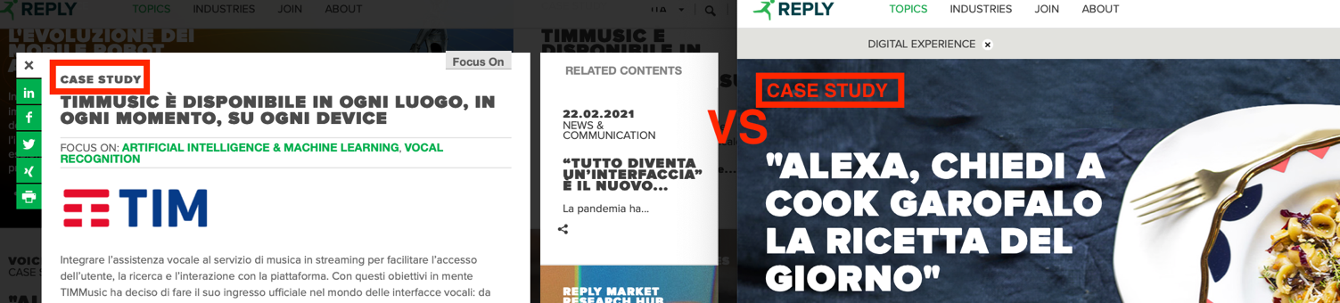



Screenshot 17: <https://www.reply.com/it/topics/artificial-intelligence-and-machine-learning>

|  |  |  |
| --- | --- | --- |
| **Heuristic Type** | **Heuristic** | **Overall Score** |
| MILE Navigation | Group navigation | 0 |

The navigation flow is not smooth. As shown in Screenshot 18, the system does not provide any useful button to move between articles on the same topic. Indeed, the breadcrumb, when displayed, only allows user to return to the home page and not to reach intermediate pages.

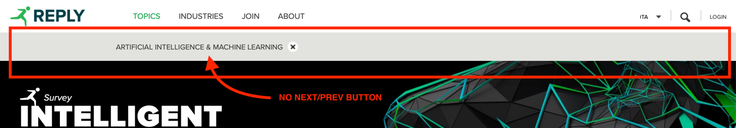

Screenshot 18: <https://www.reply.com/it/topics/artificial-intelligence-and-machine-learning/>

|  |  |  |
| --- | --- | --- |
| **Heuristic Type** | **Heuristic** | **Overall Score** |
| MILE Navigation | Structural navigation | 3 |

It is easy to navigate among all the parts of a topic since everything is displayed on a single page. However, this approach leads to a bit of confusion: too many elements make it difficult to find what you are really looking for. This problem is clearly visible from Screenshot 19.

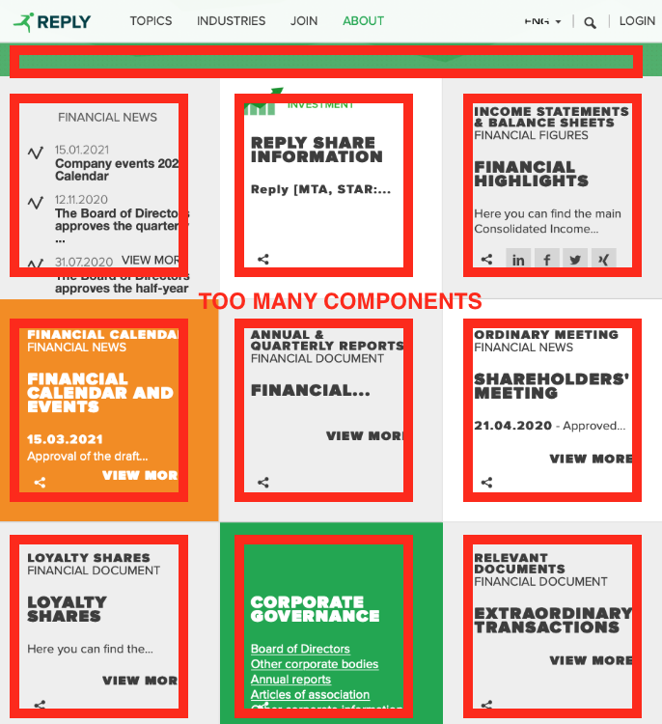

Screenshot 19: <https://www.reply.com/en/investors/>

|  |  |  |
| --- | --- | --- |
| **Heuristic Type** | **Heuristic** | **Overall Score** |
| MILE Navigation | Semantic navigation | 4 |

This heuristic is satisfied where applicable. Some articles come with a sidebar that shows related topics so that the user can easily access them (Screenshot 20). However, this useful function is not available for all the articles.

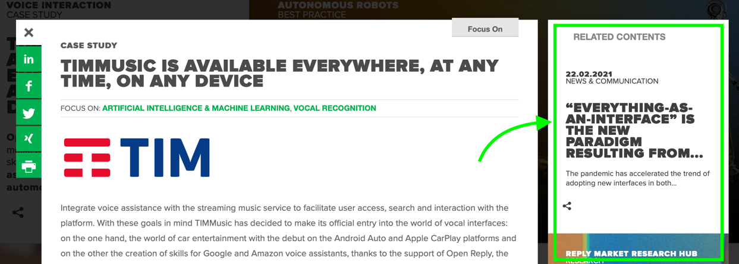

Screenshot 20: <https://www.reply.com/it/topics/artificial-intelligence-and-machine-learning/>

|  |  |  |
| --- | --- | --- |
| **Heuristic Type** | **Heuristic** | **Overall Score** |
| MILE Navigation | Landmarks | 5 |

This heuristic is fully satisfied. Indeed, the landmarks are always available in the header of the website and they provide useful access points to the main functions and sections.

|  |  |  |
| --- | --- | --- |
| **Heuristic Type** | **Heuristic** | **Overall Score** |
| MILE Content | Information overload | 1 |

Every page of the website is really crowded with information, which leads to an overload as can be seen in Screenshot 21. For instance, the home page contains dozens of articles with long descriptions, details on upcoming events and upcoming webinars, and also information on the latest press releases.

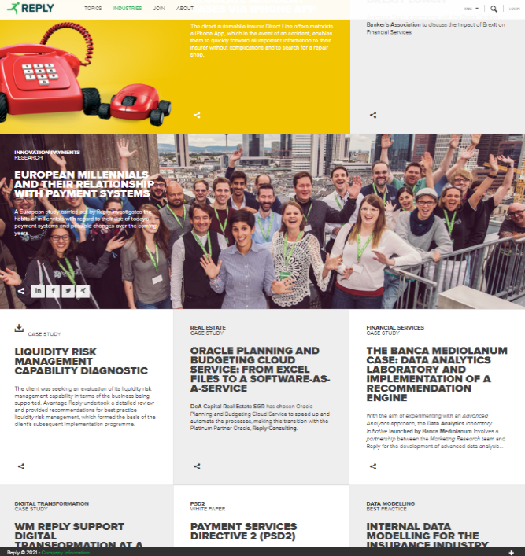

Screenshot 21: <https://www.reply.com/en/industries/financial-services/>

|  |  |  |
| --- | --- | --- |
| **Heuristic Type** | **Heuristic** | **Overall Score** |
| MILE Presentation | Text layout | 5 |

Despite that in many cases the website uses an image as a background, the text is always clearly readable, and the font size is appropriate (Screenshot 22).



Screenshot 22: <https://www.reply.com/en/topics/supply-chain-management/>

|  |  |  |
| --- | --- | --- |
| **Heuristic Type** | **Heuristic** | **Overall Score** |
| MILE Presentation | Interaction placeholders-semiotics | 5 |

The heuristic is fully satisfied. Indeed, the main used icons are the standardized ones and reflect the meaning of the interaction and its effects. For instance, the share icon and the search button result in actions that are what the user expects.

|  |  |  |
| --- | --- | --- |
| **Heuristic Type** | **Heuristic** | **Overall Score** |
| MILE Presentation | Interaction placeholders-consistency | 5 |

The placeholders are commonly shared across all the pages. Also, their position is always the same, in order to be easily reachable and recognisable for the users.

|  |  |  |
| --- | --- | --- |
| **Heuristic Type** | **Heuristic** | **Overall Score** |
| MILE Presentation | Spatial allocation | 5 |

Pages have a simple but efficient layout, consisting of a header for navigation and search, a body with related articles and a footer with “contact us” information.

|  |  |  |
| --- | --- | --- |
| **Heuristic Type** | **Heuristic** | **Overall Score** |
| MILE Presentation | Consistency of Page Structure | 3 |

Almost all the main pages of the website share the same basic structure. However, many articles often have totally different structures: some are shown as pop-ups, others as stand-alone pages despite dealing with the same type of information. The different structure (Screenshot 23) causes a sense of disorientation in the user.



Screenshot 23: <https://www.reply.com/it/topics/artificial-intelligence-and-machine-learning/>

# A Inspection Annex

This chapter contains the complete individual reports of the inspections on the usability of the Reply website.

## A.1 Individual Inspection 1

|  |  |  |  |  |
| --- | --- | --- | --- | --- |
| **Inspector:** Luca Leoni | | | | |
| **Heuristic Type** | **Heuristic** | **Score** | **Comment** | **Reference** |
| Nielsen | Visibility of system status | 1 | Despite the website retains the information about the status, the breadcrumb is badly implemented. The user is not aware of the presence of it. Indeed, it is not clearly shown as a status bar. A kind of Location-Based Breadcrumb is implemented, but not in an intuitive way. | Screenshot 1. 1 |



Screenshot 1. 1 <https://www.reply.com/en/industries/logistics-and-manufacturing/>

|  |  |  |  |  |
| --- | --- | --- | --- | --- |
| **Heuristic Type** | **Heuristic** | **Score** | **Comment** | **Reference** |
| Nielsen | Match between system and the real world | 4 | The only problem is related to the partial translation of the principal labels. In fact, the main labels are only in English, so, they could not appear natural and logical to the users. | Screenshot 1. 2 |



Screenshot 1. 2 <https://www.reply.com>

|  |  |  |  |  |
| --- | --- | --- | --- | --- |
| **Heuristic Type** | **Heuristic** | **Score** | **Comment** | **Reference** |
| Nielsen | User control and freedom | 4 | In the majority of the cases, you can at most perform 3 steps. From the Homepage to a specific showcase (you can go back through the x button) and from there to a specific page. In this case, we have to differentiate the case in which a new panel is opened and the case in which appears a window.  PANEL: you can go back simply by closing the panel.  WINDOW: an x button will show and through that you can return to the previous page. | - |
| Nielsen | Consistency and standards | 5 | The essential standards are respected, such as the login button, search box, exit button and share icons. | Screenshot 1. 3 |

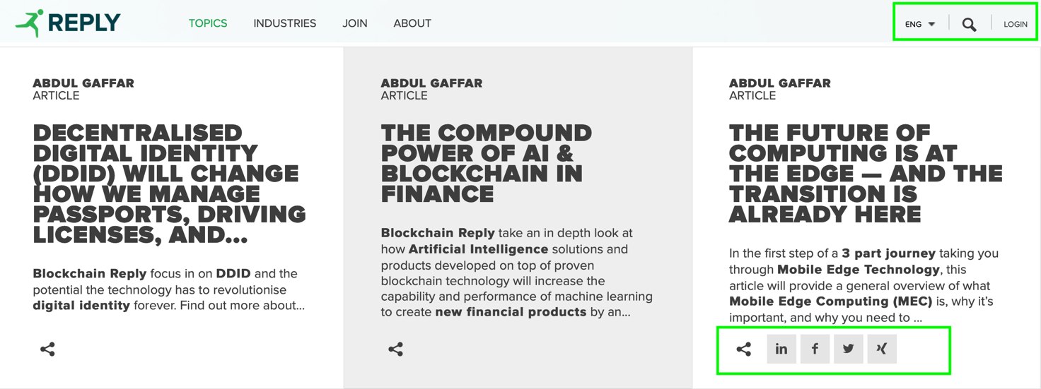

Screenshot 1. 3 <https://www.reply.com/en/blockchain>

|  |  |  |  |  |
| --- | --- | --- | --- | --- |
| **Heuristic Type** | **Heuristic** | **Score** | **Comment** | **Reference** |
| Nielsen | Error prevention | 3 | The system presents some weaknesses. For instance, when a new user performs the Registration process, only after confirming the request, the system checks if the rules concerning password or email are followed. | Screenshot 1. 4 |

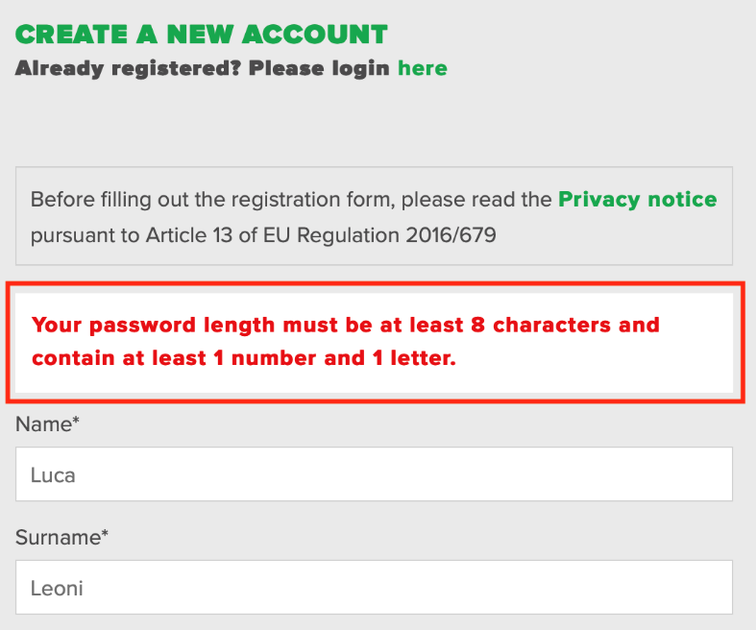

Screenshot 1. 4 <https://www.reply.com/en/register>

|  |  |  |  |  |
| --- | --- | --- | --- | --- |
| **Heuristic Type** | **Heuristic** | **Score** | **Comment** | **Reference** |
| Nielsen | Recognition rather than recall | 2 | The system does not provide any suggestions when a user tries to search for something. Despite that, in the Webinar section, it has been implemented a live filtering search box (every time the user types a letter, the system checks and shows only the matching results). | Screenshot 1. 5 |

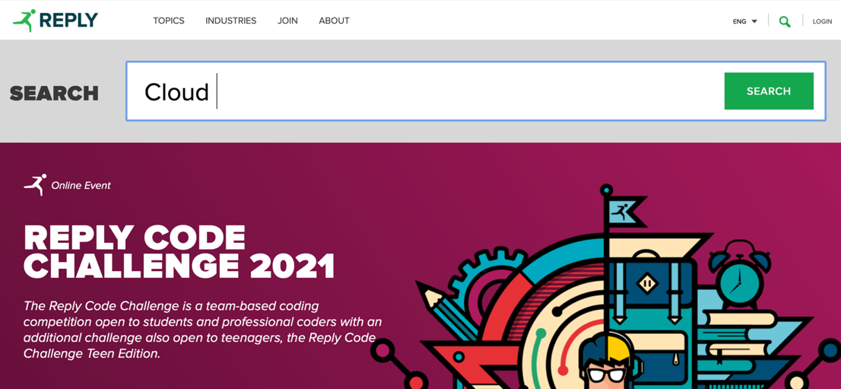

Screenshot 1. 5 <https://www.reply.com>

|  |  |  |  |  |
| --- | --- | --- | --- | --- |
| **Heuristic Type** | **Heuristic** | **Score** | **Comment** | **Reference** |
| Nielsen | Flexibility and efficiency of use | 4 | The navigation through the header is not helpful. Indeed, there are too many categories and the users could be disoriented. | - |
| Nielsen | Aesthetic and minimalist design | 0 | The whole website is crowded with information. There are too many subcategories in each section. The Homepage acts as a showcase with all the articles of the website. Despite that, the aesthetic is good. | Screenshot 1. 6 |

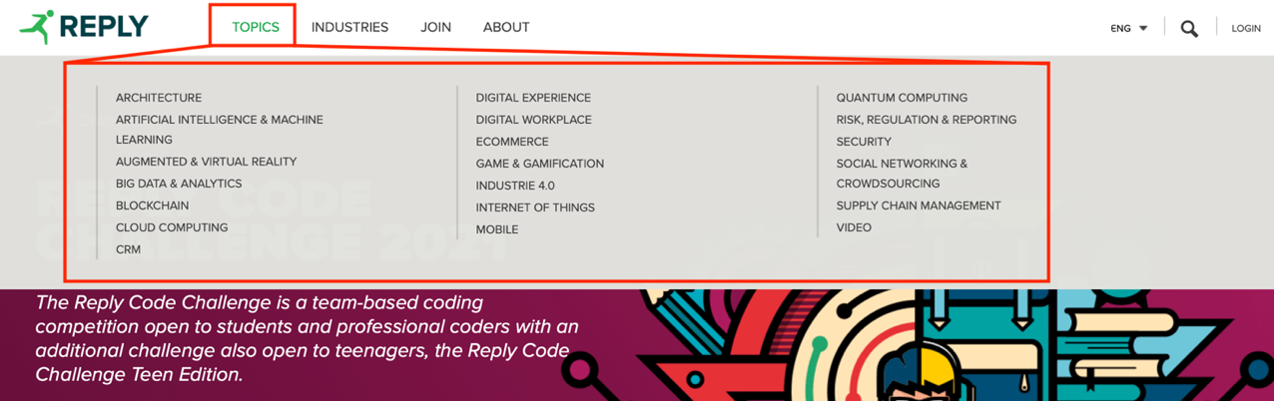

Screenshot 1. 6 <https://www.reply.com>

|  |  |  |  |  |
| --- | --- | --- | --- | --- |
| **Heuristic Type** | **Heuristic** | **Score** | **Comment** | **Reference** |
| Nielsen | Help users recognize, diagnose and recover from errors | 1 | The heuristic is not satisfied in several cases. If a user searches through the search box and commits a typo the system is able to detect it, but it does not show the correct answers. Also, in the Webinar section happens the same. Furthermore, during the login process, if a user writes the wrong email or password, the system notifies the user with a generic error message. | Screenshot 1. 7  Screenshot 1. 8 |

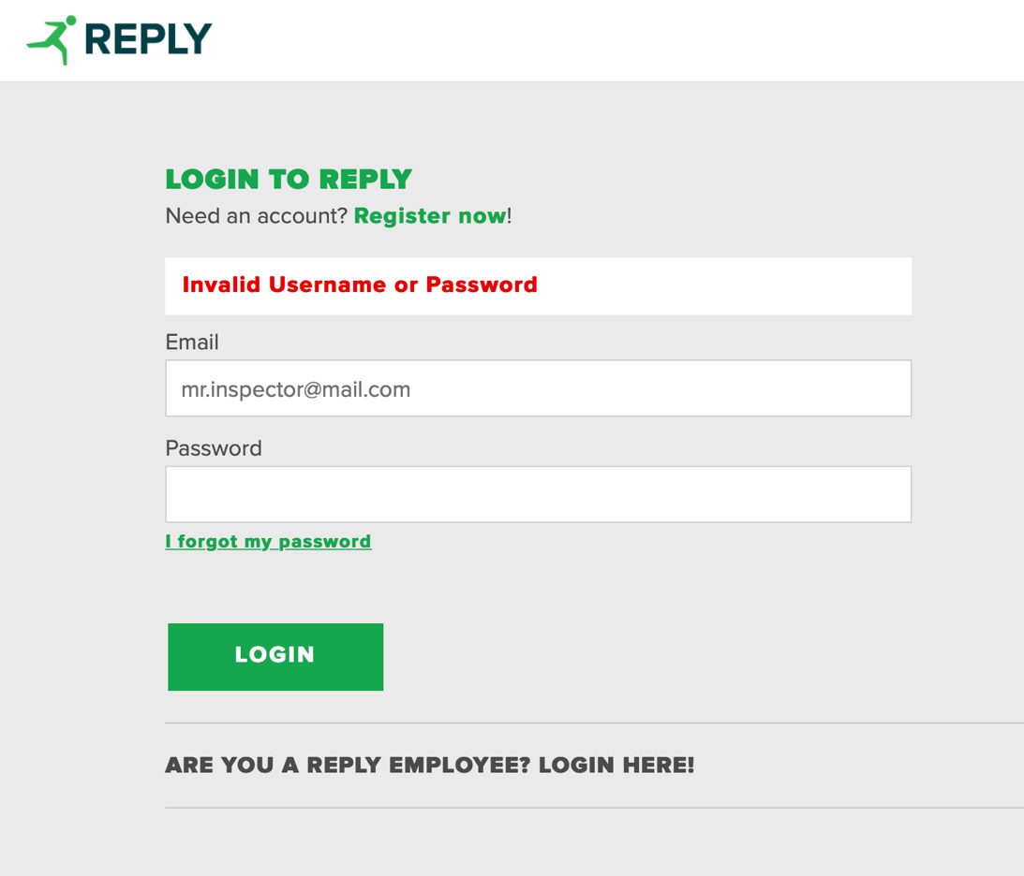

Screenshot 1. 7 [https://www.reply.com/en/login](https://stscorp.reply.com/adfs/ls/?wa=wsignin1.0&wtrealm=urn%3areplyeu%3awww&wctx=https%3a%2f%2fwww.reply.com%2fen%2f_layouts%2f15%2fAuthenticate.aspx%3fSource%3d%252Fen%252Fblockchain)

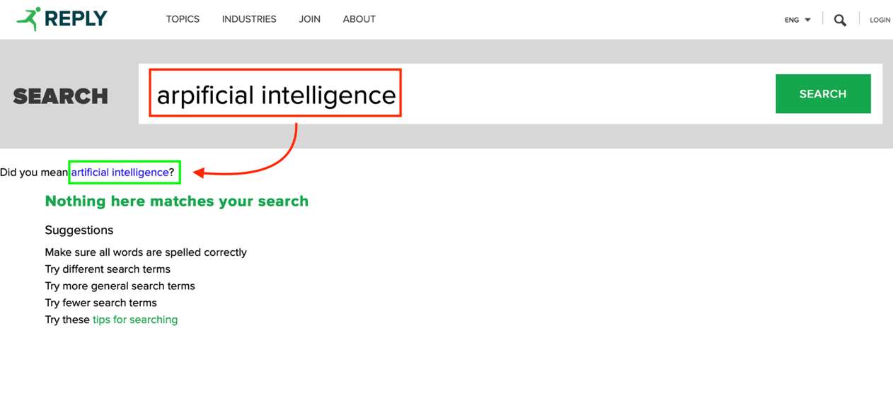

Screenshot 1. 8 <https://www.reply.com/en/search?k=arpificial%20intelligence>

|  |  |  |  |  |
| --- | --- | --- | --- | --- |
| **Heuristic Type** | **Heuristic** | **Score** | **Comment** | **Reference** |
| Nielsen | Help and documentation | N/A | - | - |
| MILE Navigation | Interaction consistency | 5 | The steps to be followed are always the same. | - |
| MILE Navigation | Group navigation | 0 | The flow is not stable. Indeed, due to the leak of breadcrumb, the user cannot navigate through the different pages without restarting from scratch. | Screenshot 1. 9 |



Screenshot 1. 9 <https://www.reply.com/en/industries/retail-and-consumer-products/>

|  |  |  |  |  |
| --- | --- | --- | --- | --- |
| **Heuristic Type** | **Heuristic** | **Score** | **Comment** | **Reference** |
| MILE Navigation | Structural Navigation | 3 | The website presents too many components. Despite that, it is simple to explore all the parts of a topic since they are all displayed on a single page. | - |
| MILE Navigation | Semantic Navigation | 4 | Sometimes N/A. When applicable, the articles are displayed, joined with related posts. | - |
| MILE Navigation | Landmarks | 4 | The landmarks are always available. Despite that, they are full of information and sometimes the user does not know in advance exactly where he has to go to find information. | - |
| MILE Content | Information overload | 0 | The Homepage is full of information. It contains all the articles posted on the website. | Screenshot 1. 10 |

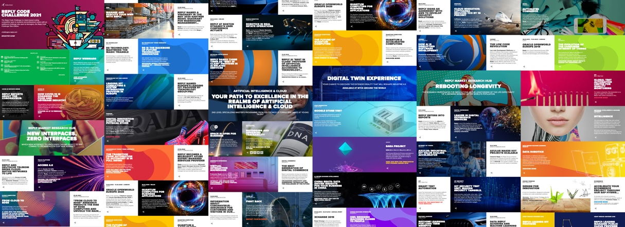

Screenshot 1. 10 <https://www.reply.com>

|  |  |  |  |  |
| --- | --- | --- | --- | --- |
| **Heuristic Type** | **Heuristic** | **Score** | **Comment** | **Reference** |
| MILE Presentation | Text layout | 5 | Despite that in many cases the website uses an image as a background, the text is readable. | Screenshot 1. 11 |



Screenshot 1. 11 <https://www.reply.com/en/topics/supply-chain-management/>

|  |  |  |  |  |
| --- | --- | --- | --- | --- |
| **Heuristic Type** | **Heuristic** | **Score** | **Comment** | **Reference** |
| MILE Presentation | Interaction placeholders-semiotics | 5 | The main icons follow the standard design. E.g., Login button, Search function, Share contents | - |
| MILE Presentation | Interaction placeholders-consistency | 5 | On each page, the placeholders are available in the same position and with the same aspect. | - |
| MILE Presentation | Spatial allocation | 5 | The pages have all the same structure: header, body and footer. Notice that, sometimes the pages are too long, due to information overload. | - |
| MILE Presentation | Consistency of Page Structure | 4 | The heuristic is not satisfied in some cases. Indeed, sometimes a new page appears as a pop-up window, while sometimes it is opened in a new panel. | Screenshot 1. 12 |

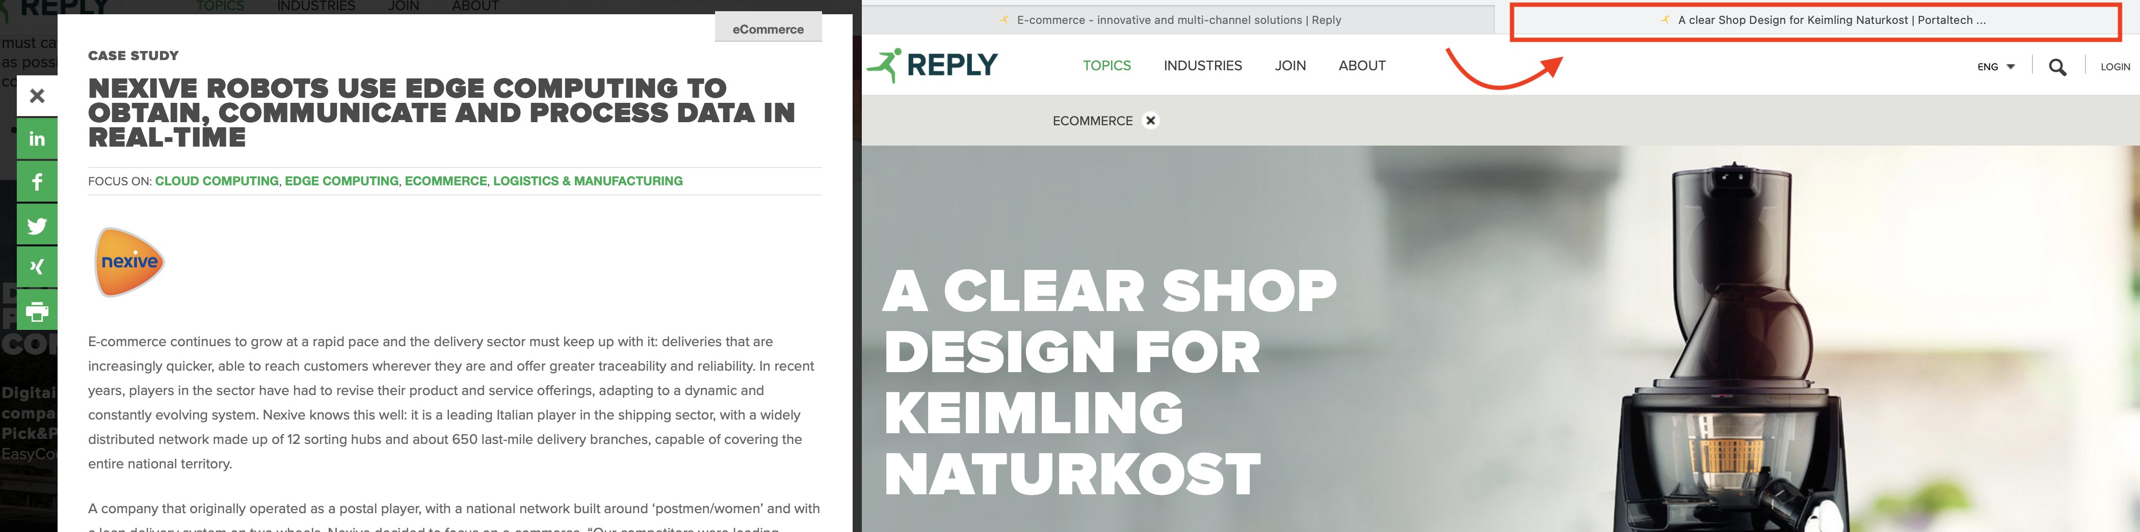

Screenshot 1. 12: <https://www.reply.com/en/topics/ecommerce/>

## A.2 Individual Inspection 2

|  |  |  |  |  |
| --- | --- | --- | --- | --- |
| **Inspector:** Luca Minotti | | | | |
| **Heuristic Type** | **Heuristic** | **Score** | **Comment** | **Reference** |
| Nielsen | Visibility of system status | 1 | Breadcrumbs do not clearly show where the user is in the website hierarchy. Their implementation is extremely counterintuitive. | Screenshot 2. 1 |



Screenshot 2. 1: <https://www.reply.com/en/investors/news>

|  |  |  |  |  |
| --- | --- | --- | --- | --- |
| **Heuristic Type** | **Heuristic** | **Score** | **Comment** | **Reference** |
| Nielsen | Match between system and the real world | 3 | The system mainly uses words familiar to the user. However, several pages of the website as well as the navigation bar, the search bar and error messages are shown in English regardless of the language chosen by the user. | Screenshot 2. 2  Screenshot 2. 3 |



Screenshot 2. 2: <https://www.reply.com/it/investors/notizie>



Screenshot 2. 3: <https://www.reply.com/it/filenotfound>

|  |  |  |  |  |
| --- | --- | --- | --- | --- |
| **Heuristic Type** | **Heuristic** | **Score** | **Comment** | **Reference** |
| Nielsen | User control and freedom | 5 | Where applicable, the user can always modify a previous choice without having to start over. For example, when filtering the upcoming events, the user always has the possibility to modify the wrong choice of the date range. | Screenshot 2. 4 |



Screenshot 2. 4: <https://www.reply.com/en/newsroom/events>

|  |  |  |  |  |
| --- | --- | --- | --- | --- |
| **Heuristic Type** | **Heuristic** | **Score** | **Comment** | **Reference** |
| Nielsen | Consistency and standards | 5 | The website is consistent in the terminologies used and adheres to design standards (e.g., login button at the top right, standard icons for searching, sharing and closing pop-up windows, burger menu for the mobile version) | Screenshot 2. 5 |

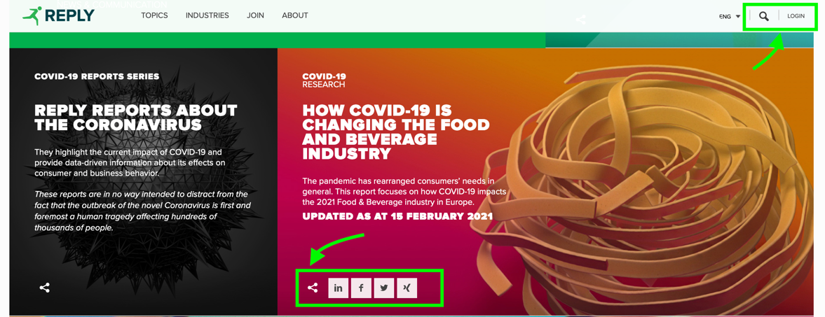

Screenshot 2. 5: <https://www.reply.com>

|  |  |  |  |  |
| --- | --- | --- | --- | --- |
| **Heuristic Type** | **Heuristic** | **Score** | **Comment** | **Reference** |
| Nielsen | Error prevention | 3 | The system correctly requests confirmation to carry out some operations that the user may incorrectly select, such as deleting the account. However, sections such as the registration one need significant improvements (here the user has no way of knowing the password security requirements before submitting the form). | Screenshot 2. 6  Screenshot 2. 7 |



Screenshot 2. 6: <https://www.reply.com/en/userprofile>



Screenshot 2. 7: <https://www.reply.com/en/register>

|  |  |  |  |  |
| --- | --- | --- | --- | --- |
| **Heuristic Type** | **Heuristic** | **Score** | **Comment** | **Reference** |
| Nielsen | Recognition rather than recall | 2 | The system does not provide any suggestions for filling in some fields during registration or when searching the site using the appropriate function. | - |
| Nielsen | Flexibility and efficiency of use | 4 | Heuristics satisfied when applicable. For example, the system allows the insertion of dates both through the textboxes (inexperienced user) and through the calendar icon (accelerator for expert user). However, some flexibility improvements can be made. For example, when searching for a webinar, the search form does not allow you to select dates in the past. To view past webinars, you need to visit another section, which is counterintuitive. | Screenshot 2. 8  Screenshot 2. 9 |



Screenshot 2. 8: <https://www.reply.com/en/newsroom/news>



Screenshot 2. 9: <https://webinars.reply.com/>

|  |  |  |  |  |
| --- | --- | --- | --- | --- |
| **Heuristic Type** | **Heuristic** | **Score** | **Comment** | **Reference** |
| Nielsen | Aesthetic and minimalist design | 2 | The homepage shows too much information making it difficult to find what you are interested in. Even the menu items (e.g., Topics) in the top bar are too many and are not organized into further sub-categories, causing confusion. | Screenshot 2. 10 |

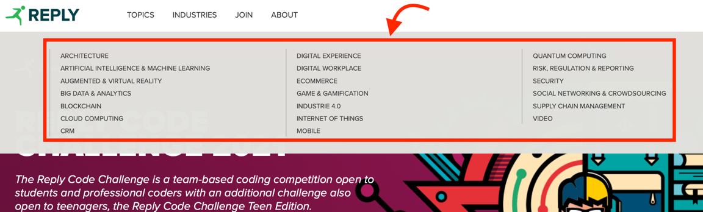

Screenshot 2. 10: <https://www.reply.com/en/>

|  |  |  |  |  |
| --- | --- | --- | --- | --- |
| **Heuristic Type** | **Heuristic** | **Score** | **Comment** | **Reference** |
| Nielsen | Help users recognize, diagnose and recover from errors | 1 | Some errors such as the page not found error are accompanied by a short explanation message, while others simply show a code and give no indication of what went wrong. | Screenshot 2. 11 |

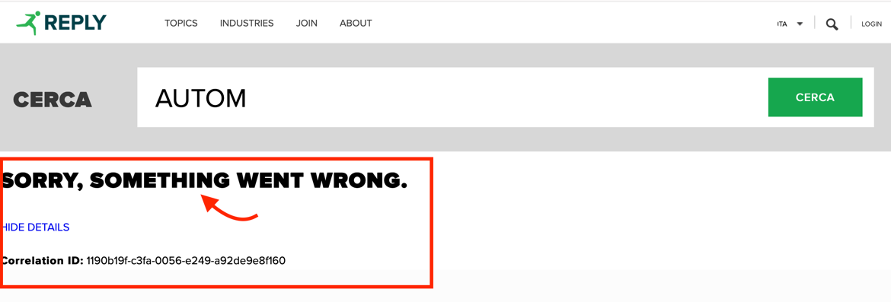

Screenshot 2. 11: <https://www.reply.com/en/search>

|  |  |  |  |  |
| --- | --- | --- | --- | --- |
| **Heuristic Type** | **Heuristic** | **Score** | **Comment** | **Reference** |
| Nielsen | Help and documentation | N/A | - | - |
| MILE Navigation | Interaction consistency | 4 | Almost satisfied. However, some case study articles open as a pop-up, while others open as a new tab | - |
| MILE Navigation | Group navigation | 0 | To move from one article to another or from one topic to another, the user must start over, making navigation difficult. Breadcrumb also do not provide any useful action to go back. | Screenshot 2. 12 |

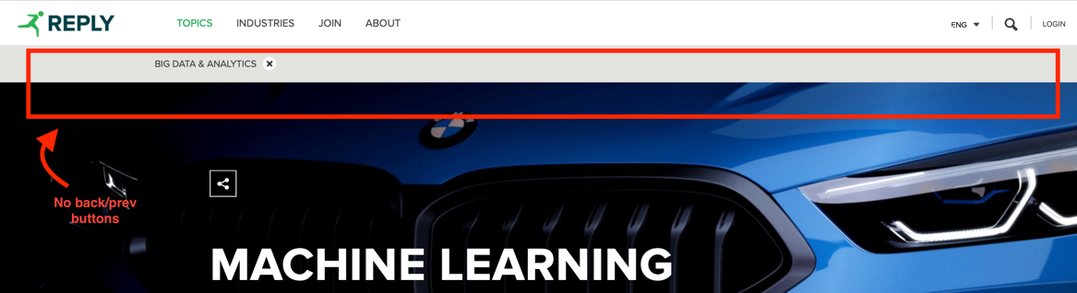

Screenshot 2. 12: <https://www.reply.com/en/topics/>

|  |  |  |  |  |
| --- | --- | --- | --- | --- |
| **Heuristic Type** | **Heuristic** | **Score** | **Comment** | **Reference** |
| MILE Navigation | Structural Navigation | 3 | The problems are concentrated on the homepage of the website and in the Investors section: too many components make it difficult to navigate between them and easily find what you are looking for. | Screenshot 2. 13 |



Screenshot 2. 13: <https://www.reply.com/en/investors/>

|  |  |  |  |  |
| --- | --- | --- | --- | --- |
| **Heuristic Type** | **Heuristic** | **Score** | **Comment** | **References** |
| MILE Navigation | Semantic Navigation | 4 | Some articles are accompanied by a sidebar that shows some related topics. However, this useful function is not available for all the articles. | Screenshot 2. 14 |



Screenshot 2. 14: <https://www.reply.com/en/content/timmusic-is-available-everywhere-at-any-time-on-any-device>

|  |  |  |  |  |
| --- | --- | --- | --- | --- |
| **Heuristic Type** | **Heuristic** | **Score** | **Comment** | **Reference** |
| MILE Navigation | Landmarks | 5 | Landmarks correctly provide useful access points to the main components of the website. | - |
| MILE Content | Information overload | 1 | The homepage and navigation drop-down menus show too much information making it easy to get lost. The information load is instead balanced in the various subsections (e.g., Topic). | Screenshot 2. 15 |

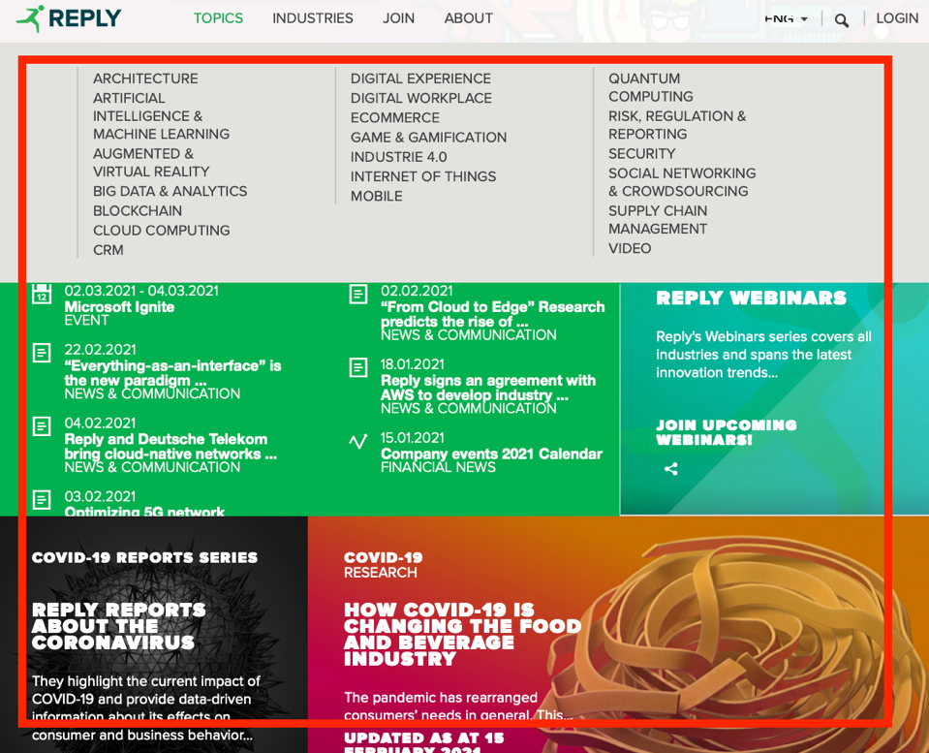

Screenshot 2. 15: <https://www.reply.com>

|  |  |  |  |  |
| --- | --- | --- | --- | --- |
| **Heuristic Type** | **Heuristic** | **Score** | **Comment** | **Reference** |
| MILE Presentation | Text layout | 5 | The text is always clearly readable. | - |
| MILE Presentation | Interaction placeholders-semiotics | 5 | No anomaly detected. | - |
| MILE Presentation | Interaction placeholders-consistency | 5 | No anomaly detected. | - |
| MILE Presentation | Spatial allocation | 5 | No anomaly detected: good spatial allocation. | - |
| MILE Presentation | Consistency of Page Structure | 2 | Almost all the main pages of the website share the same basic structure. However, many articles often have totally different structures: some are shown as pop-ups, others as stand-alone pages despite dealing with the same type of information. The different structure (Screenshot 23) causes a sense of disorientation in the user. | Screenshot 2. 16 |



Screenshot 2. 16: <https://www.reply.com/en/topics/artificial-intelligence-and-machine-learning/>

## A.3 Individual Inspection 3

|  |  |  |  |  |
| --- | --- | --- | --- | --- |
| **Inspector:** Francesco Ratti | | | | |
| **Heuristic Type** | **Heuristic** | **Score** | **Comment** | **Reference** |
| Nielsen | Visibility of system status | 1 | Breadcrumb is visible on some pages, so the user should be able to know where he/she is. The problem here is that the breadcrumb is not effective: in any section, it shows just the current section name and an X.  X meaning isn’t so clear.  Moreover, when opening an article that takes us outside of the topic page, the breadcrumb disappears. In my opinion, the breadcrumb should be fixed to the top of the viewport, so the user has not to scroll to the top of the page. | Screenshot 3. 1  Screenshot 3. 2  Screenshot 3. 3  [Reply - Offering for Enterprise Architecture & SOA](https://www.reply.com/en/topics/architecture/)  [Reply - Smart Working and the Digital Workplace](https://www.reply.com/en/topics/digital-workplace/)  (almost any page) |



Screenshot 3. 1



Screenshot 3. 2

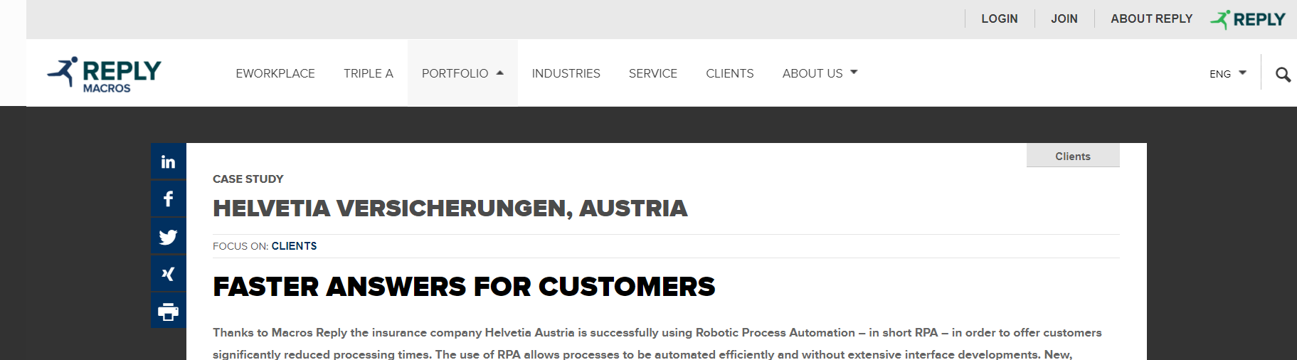

Screenshot 3. 3

|  |  |  |  |  |
| --- | --- | --- | --- | --- |
| **Heuristic Type** | **Heuristic** | **Score** | **Comment** | **Reference** |
| Nielsen | Match between system and the real world | 2 | Part of the website is in the destination language and part is still in English. | Screenshot 3. 4 |



Screenshot 3. 4

|  |  |  |  |  |
| --- | --- | --- | --- | --- |
| **Heuristic Type** | **Heuristic** | **Score** | **Comment** | **References** |
| Nielsen | User control and freedom | 5 | The user is freely able to navigate the site and leave the current page through the persistent header on top of the viewport. | Screenshot 3. 5  [Big Data Analytics: consulting, Applications, Tools | Reply](https://www.reply.com/en/topics/big-data-and-analytics/) |



Screenshot 3. 5

|  |  |  |  |  |
| --- | --- | --- | --- | --- |
| **Heuristic Type** | **Heuristic** | **Score** | **Comment** | **References** |
| Nielsen | Consistency and standards | 5 | Sharing icon coherent to standard ones (material design)  Lens icon to search which is a standard and arrow to indicate a dropdown menu when choosing the language.  Plus, minus to show more or less information and social network logos are consistent. | Screenshot 3. 6  Screenshot 3. 7  Screenshot 3. 8 |



Screenshot 3. 6



Screenshot 3. 7



Screenshot 3. 8

|  |  |  |  |  |
| --- | --- | --- | --- | --- |
| **Heuristic Type** | **Heuristic** | **Score** | **Comment** | **References** |
| Nielsen | Error prevention | 5 | Few simple items which allow navigation: upper bar menu voices and articles titles in the homepage topics: it is unambiguous that clicking on a title will lead the user to read the related article. | Screenshot 3. 5 |
| Nielsen | Recognition rather than recall | 2 | No suggestion when typing, this is a major drawback in my opinion since a user may don’t know precisely what to search on the website (he/she doesn’t know what kind of threads there are).  If the user commits a typo the system suggests the right search key, which is a great thing. | Screenshot 3. 9  Screenshot 3. 10  [Big Data Analytics: consulting, Applications, Tools | Reply](https://www.reply.com/en/topics/big-data-and-analytics/)  [Search (reply.com)](https://www.reply.com/en/search?k=machnine%20learning) |

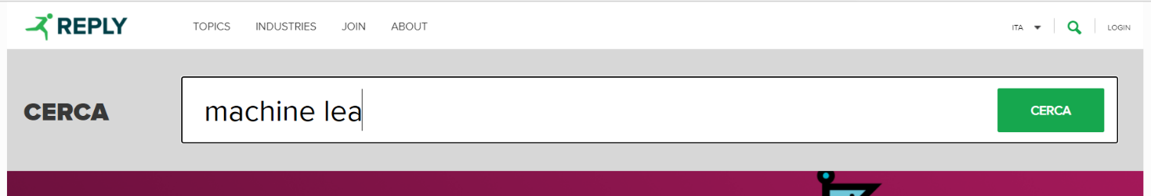

Screenshot 3. 9

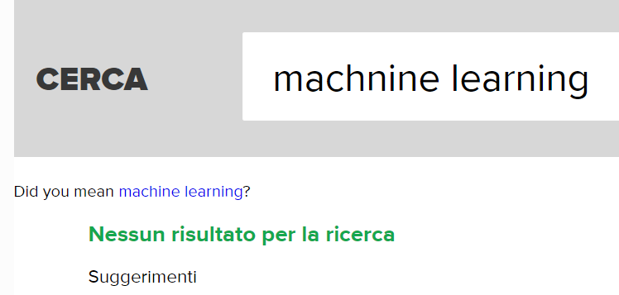

Screenshot 3. 10

|  |  |  |  |  |
| --- | --- | --- | --- | --- |
| **Heuristic Type** | **Heuristic** | **Score** | **Comment** | **References** |
| Nielsen | Flexibility and efficiency of use | 2 | Navigation through topics in the top bar menu is confusing: topics are listed and no categorisation or grouping between them. *Screenshot 3.11*  No accelerators but maybe not needed | Screenshot 3. 11 |



Screenshot 3. 11

|  |  |  |  |  |
| --- | --- | --- | --- | --- |
| **Heuristic Type** | **Heuristic** | **Score** | **Comment** | **References** |
| Nielsen | Aesthetic and minimalist design | 2 | Too many items (articles) with long descriptions in a single page.  Everything is a bit “compacted” leading to a little information explosion.  Otherwise, good design. | Screenshot 3. 12  [AI & ML - Reply Offering](https://www.reply.com/en/topics/artificial-intelligence-and-machine-learning/)  (any section and homepage) |



Screenshot 3. 12

|  |  |  |  |  |
| --- | --- | --- | --- | --- |
| **Heuristic Type** | **Heuristic** | **Score** | **Comment** | **References** |
| Nielsen | Help users recognize, diagnose and recover from errors | 1 | The login error message is expressed in plain language but does not suggest a solution neither offers a way to go back, an “insulated” page which is completely different from the previous one appears leading to disorientation in the user. | Screenshot 3. 13  [Error Page](https://stscorp.reply.com/adfs/ls/auth/integrated/?wa=wsignin1.0&wtrealm=urn%3areplyeu%3awww&wctx=https%3a%2f%2fwww.reply.com%2fen%2ftopics%2fartificial-intelligence-and-machine-learning%2f_layouts%2f15%2fAuthenticate.aspx%3fSource%3d%252Fen%252Ftopics%252Fartificial%252Dintelligence%252Dand%252Dmachine%252Dlearning) |



Screenshot 3. 13

|  |  |  |  |  |
| --- | --- | --- | --- | --- |
| **Heuristic Type** | **Heuristic** | **Score** | **Comment** | **References** |
| Nielsen | Help and documentation | N/A | - | - |
| MILE Navigation | Interaction consistency | 5 | All topic and industries pages are structured according to the same layout and interaction principles.  All of them are articles preview container, which allow reading the full article when clicked. | - |
| MILE Navigation | Group navigation | 0 | An article in open in a new tab and no “navigation button” to next or previous article of the topic we come from is shown in the breadcrumb. Moreover, there is no way to go back to the previous page to navigate to the next article from the new tab. The breadcrumb offers a way to go to the homepage only. | Screenshot 3. 14  Screenshot 3. 15 |



Screenshot 3. 14



Screenshot 3. 15

|  |  |  |  |  |
| --- | --- | --- | --- | --- |
| **Heuristic Type** | **Heuristic** | **Score** | **Comment** | **References** |
| MILE Navigation | Structural Navigation | 4 | It is easy to navigate among the parts of a topic since everything is displayed on a single page. This leads to a bit of confusion. | - |
| MILE Navigation | Semantic Navigation | 0 | An article in open in a new tab and there is no way to navigate to related articles or articles of the same topic. Each article is alone. | - |
| MILE Navigation | Landmarks | 5 | All the landmarks are located in the header. Items of the header allow us to navigate to important parts of the website. | Screenshot 3. 16 |



Screenshot 3. 16

|  |  |  |  |  |
| --- | --- | --- | --- | --- |
| **Heuristic Type** | **Heuristic** | **Score** | **Comment** | **References** |
| MILE Content | Information overload | 0 | Every page contains too many articles and text leading to an information overload in my opinion. | Screenshot 3. 17 |

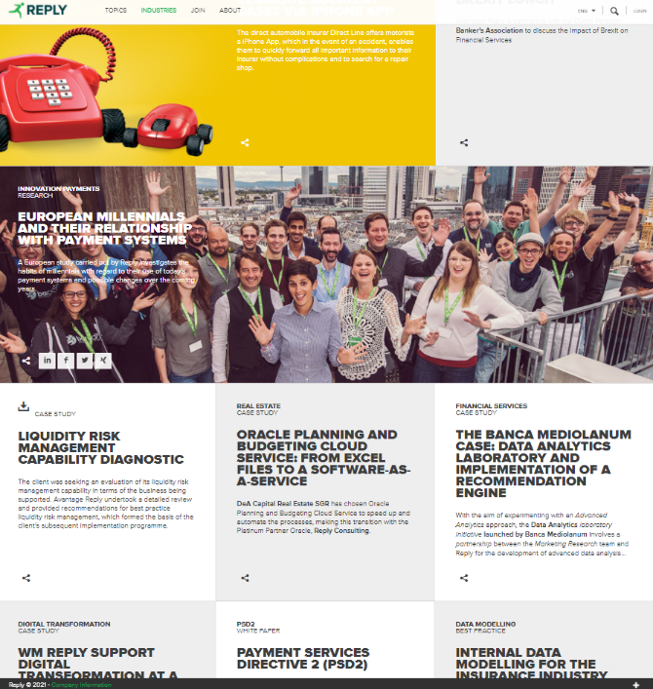

Screenshot 3. 17

|  |  |  |  |  |
| --- | --- | --- | --- | --- |
| **Heuristic Type** | **Heuristic** | **Score** | **Comment** | **References** |
| MILE Presentation | Text layout | 4 | Text is readable and the font size is generally right. Only the header top right elements are a bit small. | Screenshot 3. 18 |



Screenshot 3. 18

|  |  |  |  |  |
| --- | --- | --- | --- | --- |
| **Heuristic Type** | **Heuristic** | **Score** | **Comment** | **References** |
| MILE Presentation | Interaction placeholders-semiotics | 4 | Sharing icon coherent to standard ones (material design)  Lens icon to search which is a standard and arrow to indicate a dropdown menu when choosing the language. *Screenshot 3.6*  Plus (*screenshot 3.7*), minus to show more or less information and social network logos are consistent. *Screenshot 3.8*  The only negative part is that the items in the header are simply listed as labels with no semiotic care (no “intuitive” icons to make the most important ones easily recognisable). | Screenshot 3. 6  Screenshot 3. 7  Screenshot 3. 8 |
| MILE Presentation | Interaction placeholders-consistency | 3 | All the navigation placeholders are placed in the header, so labels positioning is correct, but the header is not fixed, so the user has to scroll to the top of the page every time.  Icons are consistent, as stated in “Interaction placeholders-semiotics” heuristic motivation.  All the topic landmarks are placed in the header in a clean label for each of them. | Screenshot 3. 19 |



Screenshot 3. 19

|  |  |  |  |  |
| --- | --- | --- | --- | --- |
| **Heuristic Type** | **Heuristic** | **Score** | **Comment** | **References** |
| MILE Presentation | Spatial allocation | 5 | Pages have a simple layout, consisting of a header for navigation, a body with related articles by category and a footer with “contact us” information. | - |
| MILE Presentation | Consistency of Page Structure | 5 | All topics and industries pages are structured according to the same layout principles, stated in the latter heuristic | - |

# 2 User Testing

User testing consists of the data collection and observation of how some representatives of real users interact with the system. User behaviours are observed, recorded and then analysed.

Its goal is to discover the actual difficulties encountered by users when interacting with the website and to obtain systematic feedback on its effectiveness and use.

## 2.1 User Testing Design

Due to the Covid-19 pandemic, the test has been designed according to some constraints. It will be held completely remotely, sharing the screen and recording the session. Test users are also encouraged to embrace the *Think Aloud* technique in order to overcome the problem of not being able to accurately analyse their behaviour. *Think Aloud* is a method invented by psychologist Édouard Claparède, which consists of externalising by voice what the user thinks and plans during task execution.

### 2.1.1 User Profile Definition

The definition of a standard user profile to test the web application allows to make the results comparable and to have reliable feedback based on multiple experiences. Here, we focus on its characteristics and on the definition of an effective recruiting technique.

#### 2.1.1.1 User Profile

Unfortunately, due to the Covid-19 pandemic and to the difficulty to physically reach people who have a proper workstation, it would have been impossible to set the user profile as the typical person who might be interested in the website. Therefore, the decision fell on *university students* or *recent graduates* between 22 and 27 years old who are *passionate about technology* and who have the minimum necessary computer skills.

Indeed, the targeted users will actually need this type of website in the near future or are familiar with this kind of application. Possible goals for them are, for example, applying for a job or keeping themselves updated on the efforts of Reply in the technological field.

#### 2.1.1.2 Recruitment strategy

The test users will be mainly selected among recent graduates or university students of the following disciplines: computer science, telecommunications and electronics. In this way, the adherence to the profile described above and the homogeneity of the sample will be guaranteed.

During the selection, it will also be essential to analyse the technological equipment available to them. Indeed, the test users must have a computer, a microphone, a webcam, an internet connection and the possibility to share the screen with their interviewers.

### 2.1.2 Usability Variables Definition

Some variables have been chosen to be measured during the execution of the tasks and by a subsequent survey for the testers. The usability variables include both quantitative and qualitative indicators and are reported in the following table.

|  |  |  |
| --- | --- | --- |
| **Usability Variable** | | **Description** |
| *V1* | *Effectiveness* | Task success rate |
| *V2* | *Efficiency* | Time needed to complete the task |
| *V3* | *Errors* | Wrong paths or actions while completing the task |
| *V4* | *Satisfaction* | Users’ feelings about the navigation experience |
| *V5* | *Disorientation* | Difficulty in understanding how to move between the shown contents |
| *V6* | *Wandering periods* | Difficulty to realize the next steps |
| *V7* | *Confidence with the design* | Difficulty in understanding what is the next step to take |

Table 1: Usability Variables

### 2.1.3 Tasks Definition

Six tasks have been created for the users to evaluate the usability of the Reply website.

To minimise the learning effect on them during the computation of effectiveness and efficiency, they have been randomised.

Since the website acts as a showcase for the company, the tasks have a medium-low difficulty and have been defined according to the user profile previously described. Indeed, these activities reflect the real possible scenarios of use for the system under consideration.

The tasks selected are detailed in the following table.

|  |  |  |
| --- | --- | --- |
| **Task** | | **Description** |
| ***T1*** | *Register to a Webinar* | You are very passionate about the world of artificial intelligence. Look for information on the latest webinar related to artificial intelligence that took place in the past. What you read will make you want to know even more, so you will decide to register for the next webinar related to this topic which will be held in Italian. |
| ***T2*** | *Locate the Milan Office* | You are interested in finding out more information about the Reply offices in Milan. In particular, you want to know the address and telephone number of the office closest to the centre of Milan. |
| ***T3*** | *Retrieve information about a game* | You are a master student with a passion for gaming and virtual reality. You have heard of a game called Theseus developed by Reply and would like to know more information about the game and the platforms for which it is available for the thesis you are writing on VR. |
| ***T4*** | *Job search* | You are an American student who graduated at the University of Illinois at Chicago in Computer Science and Engineering. You are looking for a seat in Reply. Search for a job opportunity and discover which benefits it offers. |
| ***T5*** | *Event discovery* | Your little sister is interested in computer science. Find if Reply offers some opportunities for children. You also want to stay updated about the upcoming opportunities through social networks. |
| ***T6*** | *Financial Report* | For the optional project of Accounting and Financing, you are asked to analyse in-depth several companies. One of them is Reply. Find information about the share of the company. Furthermore, find the contact information of the INTESA SANPAOLO analyst. |

Table 2: Tasks Definitions

### 2.1.4 Pilot Test

Before submitting the test to the recruited users, it has been simulated among the group members and through a candidate user. This candidate user did not take part in the test in order not to generate bias. In this way, it has been possible to minimise misunderstandings and prevent any errors in the formulation of the test from impacting the results of the study.

### 2.1.5 Post Test Questionnaire

After the session, the recruited users are asked to complete a brief questionnaire, here reported.

|  |  |
| --- | --- |
| **Part 1** | |
| **Assessment** | **How much do you agree with the following statements?**  *(1= totally disagree, 5=totally agree)* |
| *Content* | The used terminology was understandable throughout the website |
| The naming and labelling of the links were |
| Under each section of the website, the web pages were well organised |
| There was too much information on individual pages |
| *Navigation* | The navigation bar was helpful |
| It was necessary to scroll often to reach the desired information |
| It was easy to find the information I needed on the website |
| The "Search Function" was helpful and reliable |
| *Cognitive Effort* | I learned to use the website quickly |
| The navigation was always intuitive |
| While using the website I often felt disoriented |
| *Presentation* | The text shown on the website was always clearly readable |
| Pages were structured and displayed in an effective way |
| **Part 2** | |
| ***Comments*** | **If you could change one thing on this website, what would it be and why?** *(open question)* |
| **Part 3** | |
| ***Overall rate*** | **How would you rate your experience on the website?**  *(1= poor, 5=very good)* |

User Test Post Questionnaire

## 2.2 User Testing Execution

As previously described, the goal of the study is to observe the actual usage of the website in order to evaluate its usability. In the following chapters, the test and its execution are explained in a more detailed way, with a section dedicated to the data gathered, their meaning, interpretation and results.

### 2.2.1 Execution

Eight users have been recruited for the test, according to the User Profile previously defined. Before its execution, the purpose of the test and its structure were clearly explained. In particular, users know that they are free to leave the test at any time and that the examination concerns the website and not their performance.

Since the session would be online, the users are asked to share their screen, open the microphone and the webcam. All the sessions have been recorded to analyse them also in a second moment. A file (reported in section B.1) containing all the relevant information concerning the test session has been provided to the tester.

The order of the tasks has been randomised for each user in order to minimise the learning effect. Every session starts from the homepage of the website. During the execution, the moderator kept track of the time required to accomplish each task, took notes and was available for any further question by the user. At the end of the Task Phase, users were asked to fulfil a brief survey about the experience.

### 2.2.2 Data Analysis

The data collected during the execution of the test are reported in full form and analysed in this section.

* **Effectiveness**

The effectiveness of the website is analysed by detecting the degree of completion of the assigned tasks. This rate is defined as the percentage of operations carried out correctly and in a totally autonomous manner. The gathered data are reported in Table 1. Specifically, the task is considered successful (S) if completed without assistance, partial (P) if only partially completed and failed (F) if the intervention of the moderator was required to complete it. The overall success rate of the system is approximately equal to 87,5%.

|  |  |  |  |  |  |  |
| --- | --- | --- | --- | --- | --- | --- |
| **User** | **T1** | **T2** | **T3** | **T4** | **T5** | **T6** |
| **1** | S | S | S | S | S | S |
| **2** | F | S | S | S | S | S |
| **3** | P | S | S | S | S | S |
| **4** | P | S | S | S | S | S |
| **5** | S | S | S | S | F | S |
| **6** | P | S | S | S | F | P |
| **7** | S | S | S | S | S | S |
| **8** | F | S | S | S | S | S |
|  | 56% | 100% | 100% | 100% | 75% | 94% |

Table 1: Success Rate per task

Graph 1: Effectiveness Graph

As shown in Graph 1, the task with the highest incompleteness rate is *T1 (Register to a Webinar).* This fact highlights critical issues in the intuitiveness of the webinar section. During the test, many users were unable to complete this task due to the inability to reach the webinar page or difficulty in understanding its content.

The completion rate is also particularly low for *T5 (Event Discovery)*. Again, this is due to the difficulty of users in locating the link that leads to the section presenting opportunities for kids.

On the other hand, all the testers managed to pass the *T2 (Locate the Milan Office), T3(Retrieve information about a game), and T4(Job search)* tasks which means that the application has no serious shortcomings that prevent them from being completed.

* **Efficiency**

System efficiency is measured by the amount of time it takes to complete tasks. This time is defined as the time that elapses between the opening of the homepage and the instant in which the user declares to have completed the activity. The measured times are shown in Table 2.

|  |  |  |  |  |  |  |
| --- | --- | --- | --- | --- | --- | --- |
| **User** | **T1** | **T2** | **T3** | **T4** | **T5** | **T6** |
| **1** | 273 | 35 | 126 | 87 | 48 | 56 |
| **2** | 600 | 97 | 188 | 163 | 49 | 214 |
| **3** | 300 | 25 | 63 | 55 | 33 | 24 |
| **4** | 540 | 80 | 140 | 120 | 62 | 30 |
| **5** | 286 | 87 | 74 | 111 | 173 | 48 |
| **6** | 510 | 130 | 75 | 90 | 520 | 320 |
| **7** | 576 | 108 | 147 | 117 | 74 | 48 |
| **8** | 600 | 185 | 97 | 122 | 278 | 332 |
| **AVG** |  | 93 | 114 | 108 | 155 | 134 |

Table 2: Time on task in seconds

Graph 2: Efficiency Graph

The average execution time of the tasks, also shown in Graph 2, appears to be quite reasonable given their complexity. However, from the data, it can be seen that the most time-consuming activity is *T1 (Register to a Webinar*). This indicates that there are problems with the website to access the webinar sections efficiently. Indeed, users complained about the lack of a link to the webinars directly on the topics’ pages. Some testers also pointed out the need for the Webinar entry right in the navigation bar.

The experiment also found that users spend most of the time examining the large amount of information that is shown to them. This could indicate that it is necessary to reduce the information load on the pages and in the navigation menu.

* **Errors and confidence with the design**

The error variable measures the number of wrong actions or paths taken by the user while browsing. The values recorded by the moderator during the execution of the task are reported in Table 3.

|  |  |  |  |  |  |  |
| --- | --- | --- | --- | --- | --- | --- |
| **User** | **T1** | **T2** | **T3** | **T4** | **T5** | **T6** |
| **1** | 2 | 0 | 0 | 0 | 0 | 0 |
| **2** | 3 | 0 | 4 | 0 | 0 | 3 |
| **3** | 3 | 0 | 0 | 0 | 0 | 0 |
| **4** | 4 | 0 | 0 | 0 | 0 | 0 |
| **5** | 2 | 0 | 0 | 0 | 4 | 0 |
| **6** | 2 | 1 | 0 | 0 | 3 | 3 |
| **7** | 2 | 1 | 0 | 0 | 0 | 0 |
| **8** | 1 | 1 | 1 | 0 | 1 | 0 |
|  | 19 | 3 | 5 | 0 | 8 | 6 |

Table 3: Error Count

Graph 3: Errors Graph

As Graph 3 shows, task T1 is the one with the highest number of wrong actions/paths. This proves that the system has areas where navigation is not very intuitive, or the user is misled by unclear labels. Graph 4 lists the major sources of errors for users. In particular, it highlights problems in navigation: users often look for information on pages where they are not present because they do not understand the general organizational structure of the website content.

Another recurring error is related to the completion of the webinar registration form. In this case, the user is led to incorrectly complete the password field as there is no indication of the requirements that it must comply with until after submitting the form.

Graph 4: Sources of error

These issues are also confirmed by some answers given in the post-test questionnaire (Graph 5). In general, users rely on the search function integrated into the website, but not always they are able to find what they were looking for. Some of them argue that the results should also include data relating to the events or to the various opportunities offered by Reply and not be limited to articles only. The interface showing the results is also not very user friendly according to some comments.

During the experiment, often the user was not sure which keywords to type in the search box or how to write them (e.g., they were worried about typos in writing the word “Theseus”) and the system did not provide any autocomplete aid.

Strongly disagree

Strongly agree

Graph 5: Part of the post-test questionnaire

* **Satisfaction, disorientation and wandering periods**

During the test, the moderators carefully analysed the expressions and reactions of the users. These data, together with the results of the post-test questionnaire, are essential to assess the degree of satisfaction. Users generally rate the experience with the website more than positively, as reported in Graph 6.

Poor

Very good

Graph 6: Satisfaction assessment from the post-test questionnaire

The perceived feeling was mainly one of satisfaction. The periods of greatest stress and fatigue occurred, again, during the execution of task T1. This is mainly due to the fact that users have often felt disoriented in searching for specific information. As noted above, the vast majority of time was spent browsing the various pages of the website as users had a hard time finding the webinar sections and specific events.

As shown in graph 7, the general opinion is that the pages of the website often contain too much information (information overload) and that the spatial allocation of the components needs improvement. A large chunk of users started scrolling through the pages to the end showing visible disorientation.

On the other hand, testers were generally satisfied when searching for specific articles (*T5 - Event Discovery*) or when locating the company’s offices. This shows that the global search function actually helps the user and information about Reply is provided effectively.

Strongly disagree

Strongly agree

Graph 7: Part of the post-test questionnaire

Table 4 also reports the general comments collected during the test and mentioned above.

|  |  |
| --- | --- |
|  | **If you could change one thing on this website, what would it be and why?** |
| **User 1** | Often too much information is shown. Furthermore, the colours used on the website and the images shown were too many and gave a sense of confusion. |
| **User 2** | The home page contains too much information making it difficult to find what you really need. |
| **User 3** | The way the articles and various elements are displayed on the website pages is too confusing. |
| **User 4** | I would add a section in the navigation bar for searching the events and the opportunities offered by Reply. |
| **User 5** | I would add a link to the webinar section also in the various Topic sections. |
| **User 6** | I would improve the search tab with a more user-friendly interface. Furthermore, I would have preferred that in the pages about the Reply offices the "View on map" button would show the position directly on the embedded map and not in a new tab. |
| **User 7** | I would have preferred a more linear website. There is too much information on the screen and navigation suffers from this. |
| **User 8** | It was not clear if the registration procedure has been successfully completed. Thus, I would add a message which notifies the user about the completion of the request. |

Table 4: Post-test comments of the users

# 3 Final Conclusions

This chapter contains the conclusions of the usability report relating to the Reply website. The considerations made in the following sections represent the basis on which the system can be improved to provide a better user experience for end-users.

## 3.1 Comments on the results

After having completed the Inspection and having analysed the data collected during the User Testing, it is reasonable to expose a global evaluation of the website. Both, experts and recruited users allow that Reply.com is high-grade in terms of usability and design. However, it presents some weaknesses that have been already highlighted during the Inspection. Furthermore, users felt disoriented and frustrated while performing some tasks.

These vulnerabilities are mainly related to navigation. Indeed, the website does not have a proper breadcrumb that allows users to know exactly where they are. Moreover, the Topic sections are not organised adequately. On the other hand, the system does not implement error prevention. Furthermore, it does not provide any suggestion when using the Search function.

Of course, Reply.com has numerous strengths. All the testers express appreciations regarding the design and the layout of the website. No one experiences a deadlock. Indeed, they always find a way to browse the website.

## 3.2 Suggestion for Improvements

In this section are listed some improvements to fill the gaps identified during the evaluation process.

Despite most of the suggestions are quick to implement, they might significantly improve the experience for new users.

* **Implementation of a proper breadcrumb.** Indeed, users felt disoriented when browsing the website. Some testers confused the breadcrumb with a filter for the content, due to its appearance.
* **Error prevention when filling a form.** As highlighted both in the Inspection and the User Testing, the system is not able to prevent errors. For instance, most of the users failed the first attempt of choosing a password during registration, because the security requirements are revealed only after submitting the form.
* **Recognition vs Recall.** The system does not provide any suggestion when a user tries to search for something. It could be helpful for a user to provide a hint.
* **A makeover of Topic pages.** Each topic page contains too much information that makes the user disoriented. Moreover, almost all of the testers, when performing task T1 (Register to a Webinar), browsed the Topic page looking for the related webinar. It turns out that these pages do not contain any link to the Webinar section. This error is also related to incorrect Semantic Navigation.

# B User Testing Annex

## B.1 Information for Test Users





## B.2 User Test 1

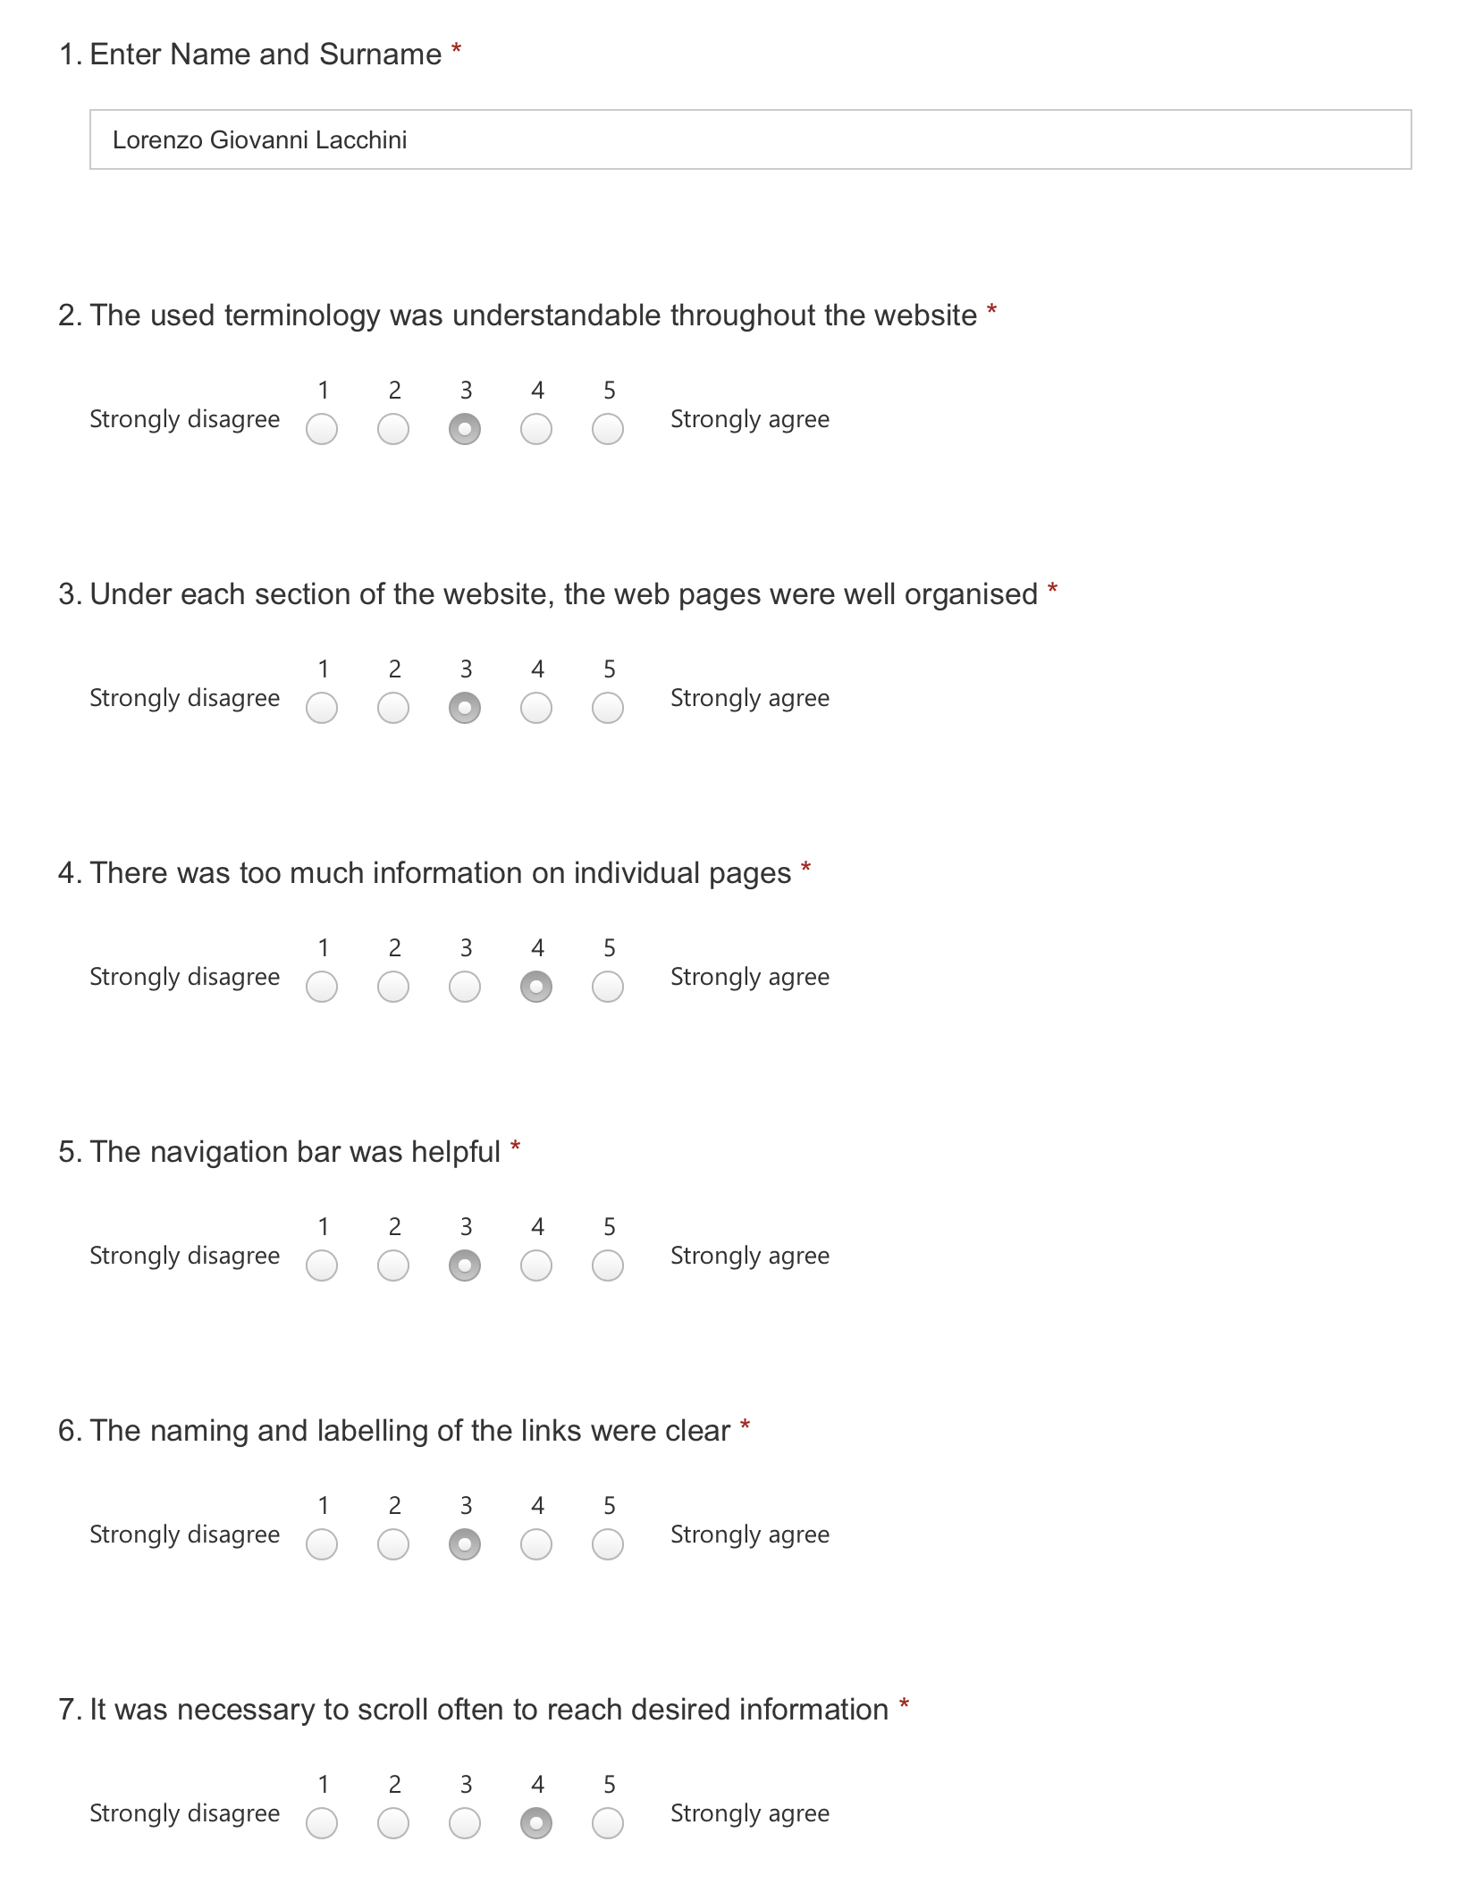

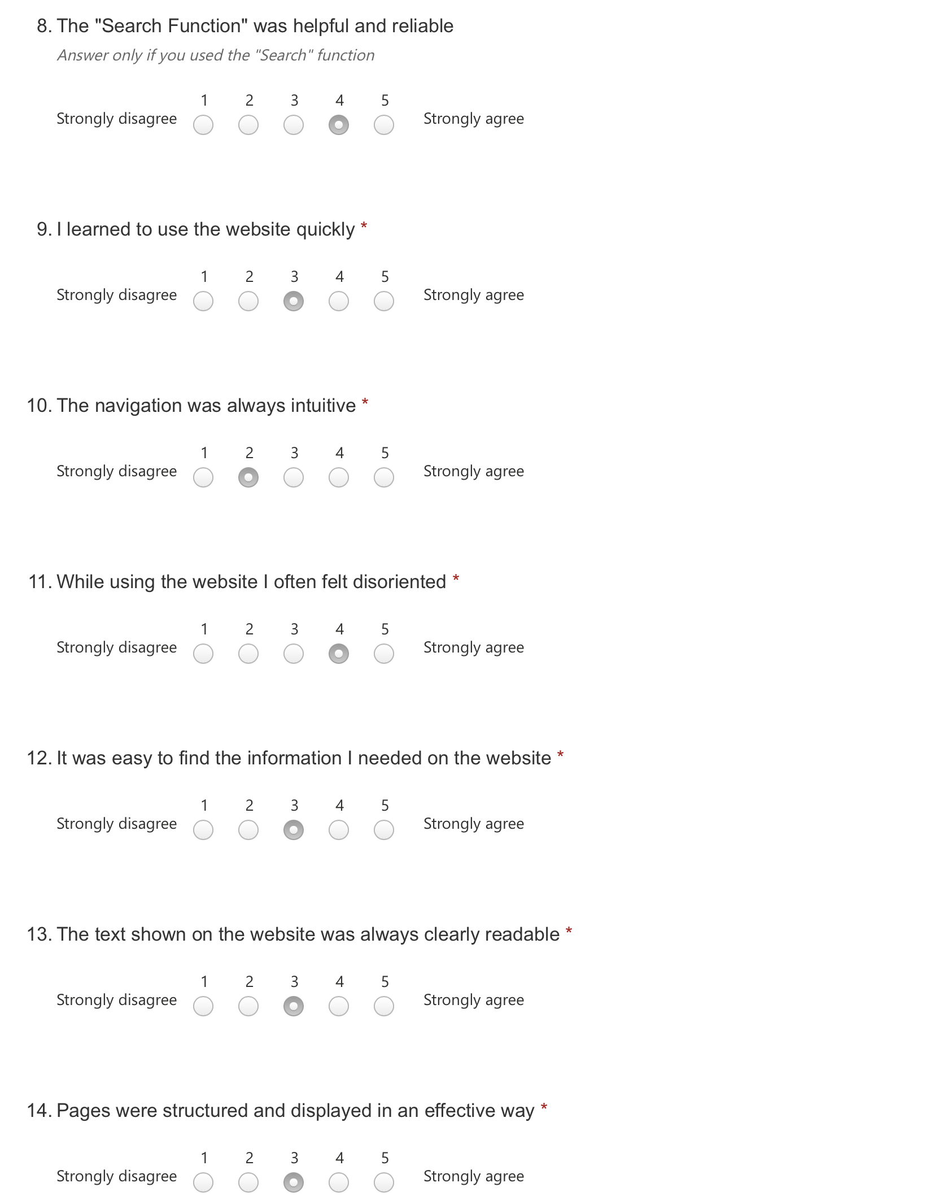

User Testing - User 1

## B.3 User Test 2

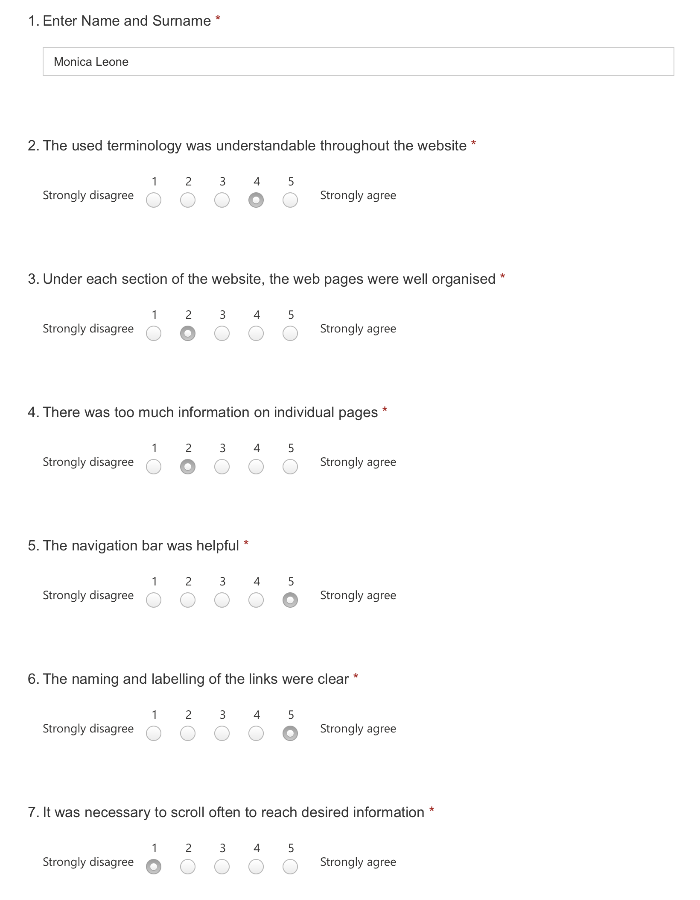

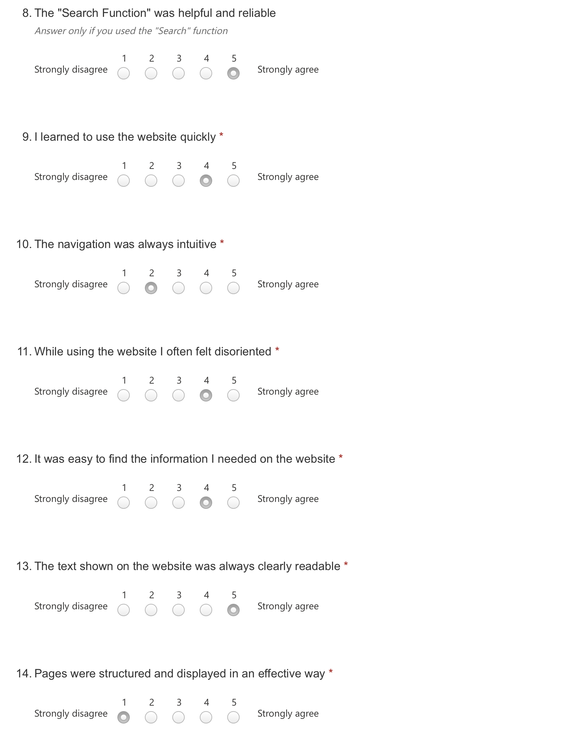

User Testing - User 2

## B.4 User Test 3

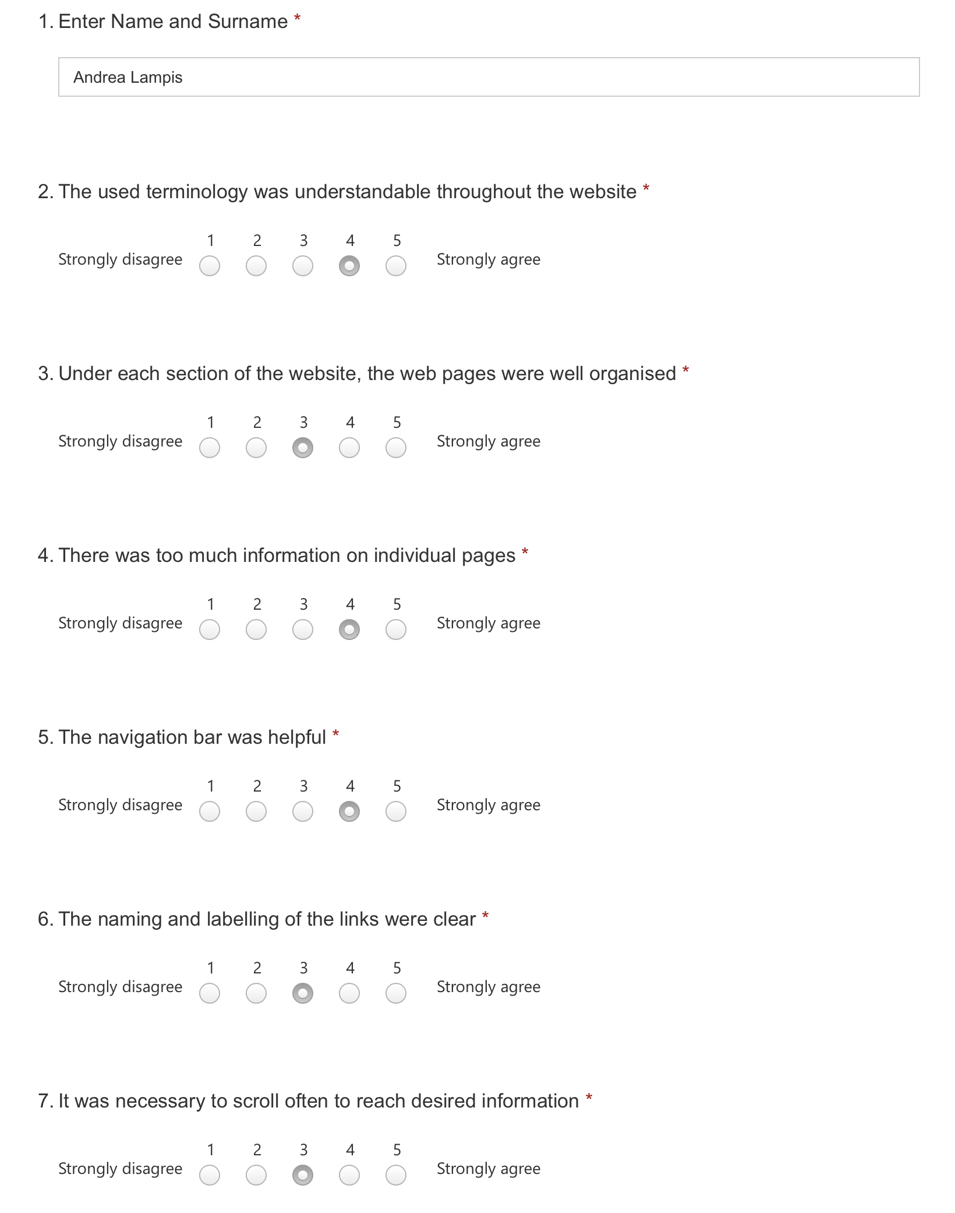

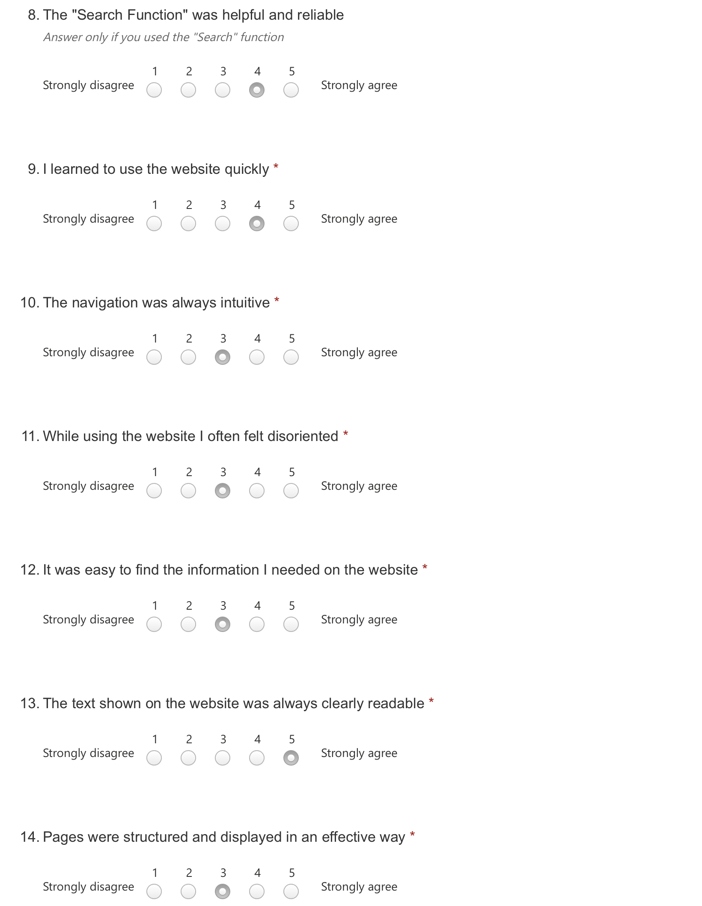

User Testing - User 3

## B.5 User Test 4

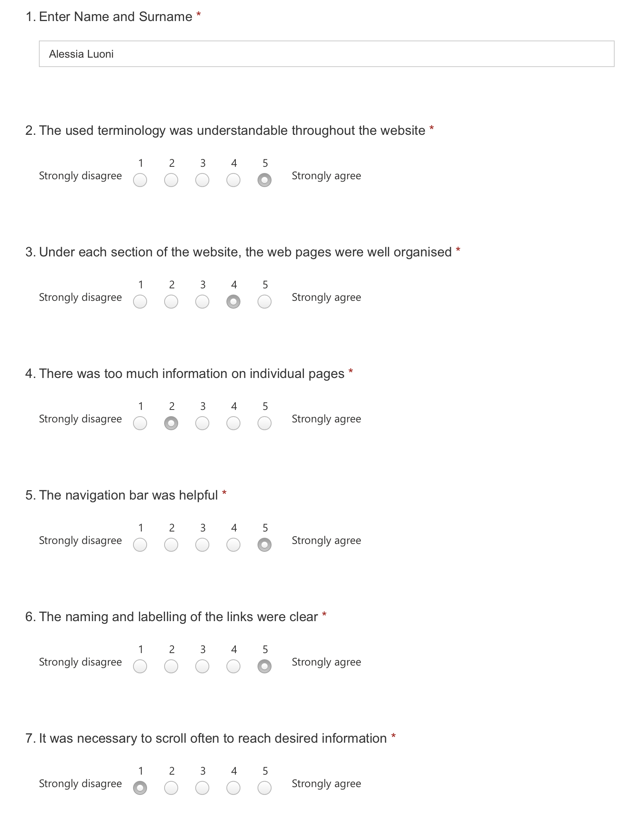

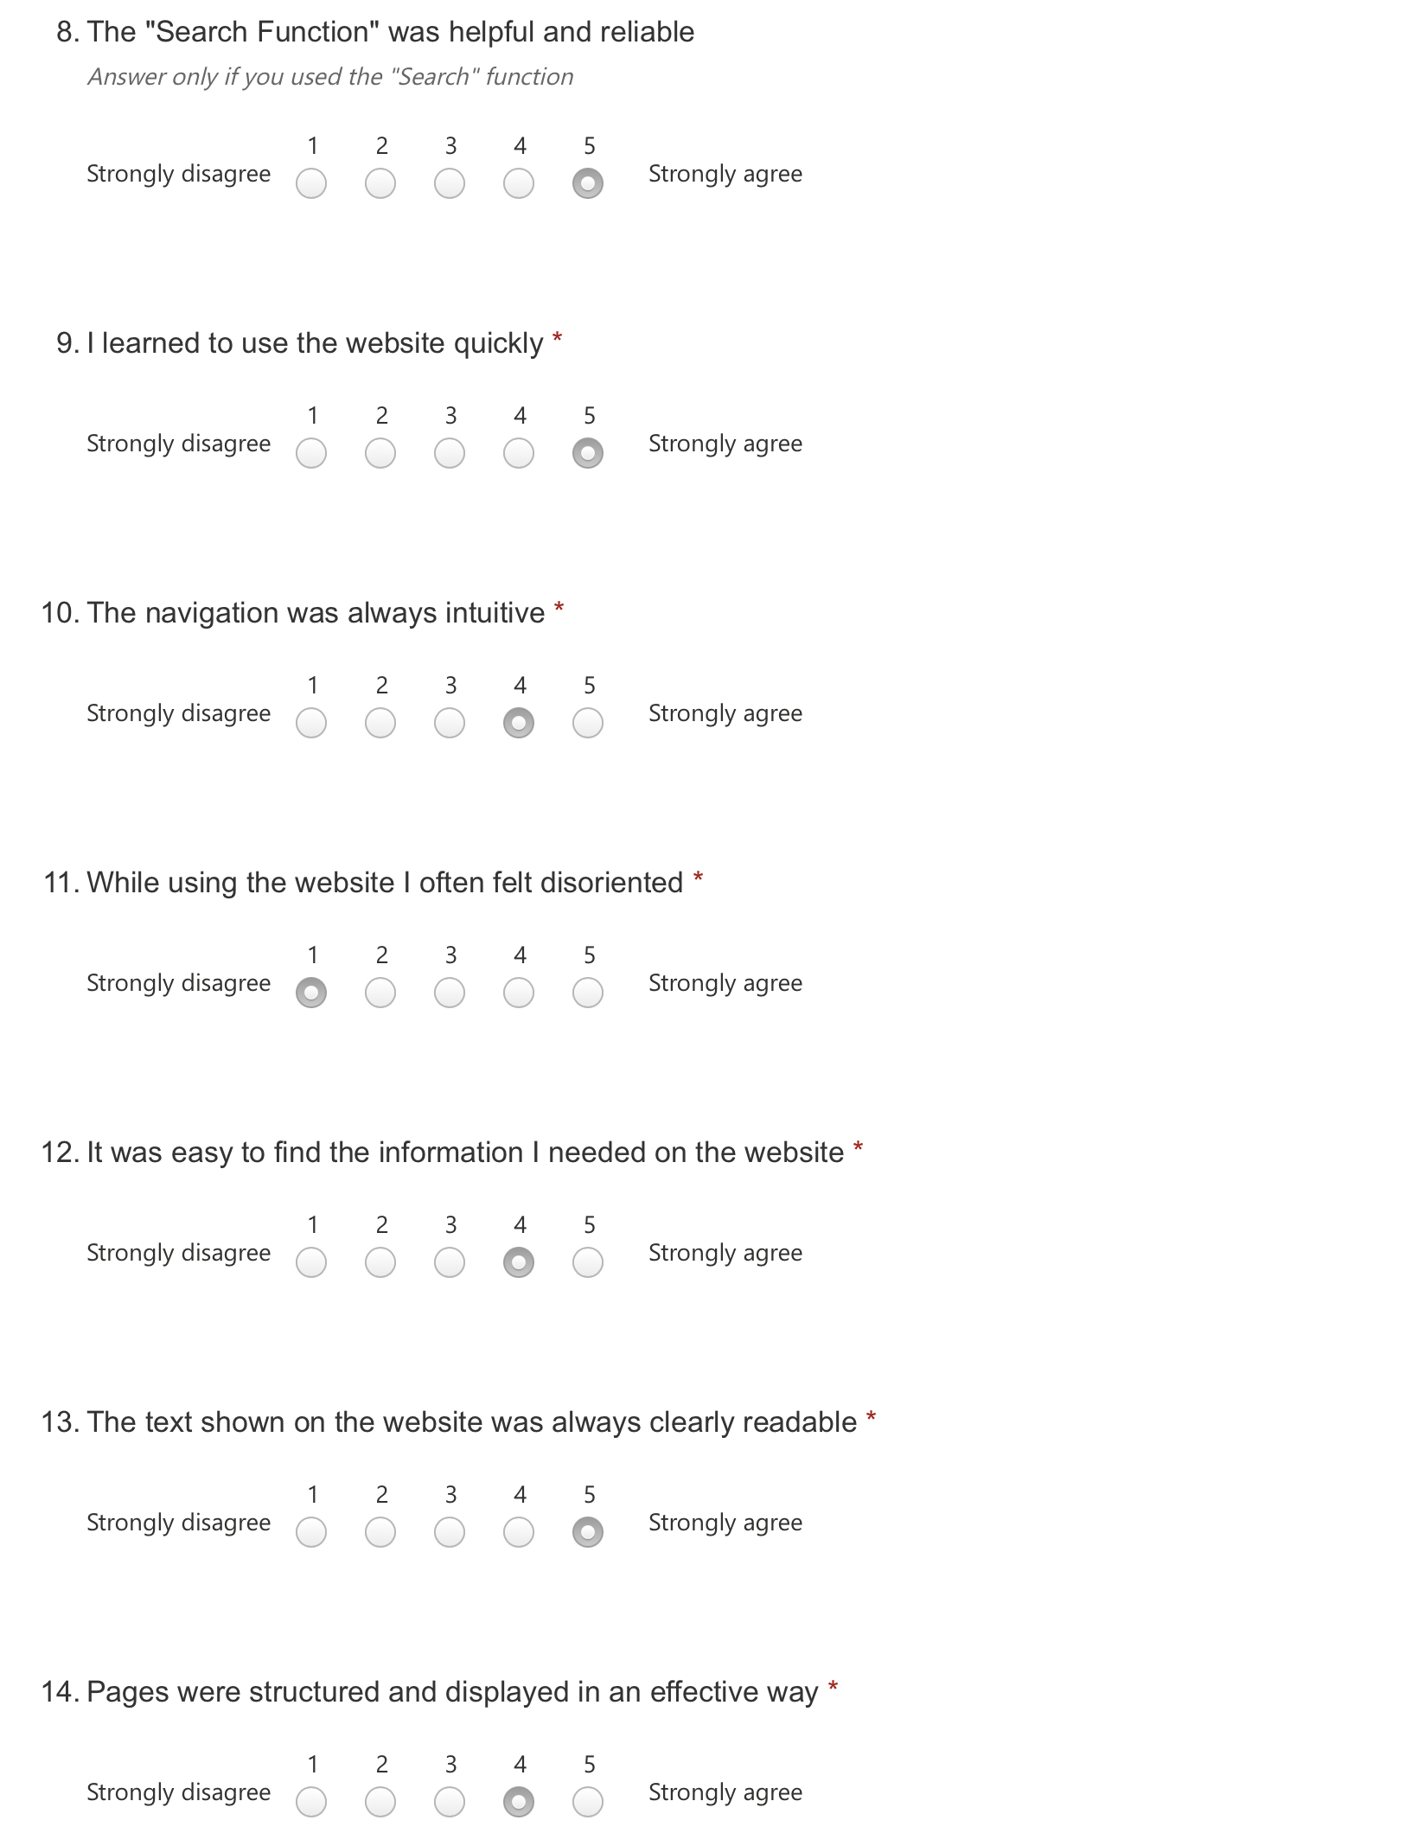

User Testing - User 4

## B.6 User Test 5

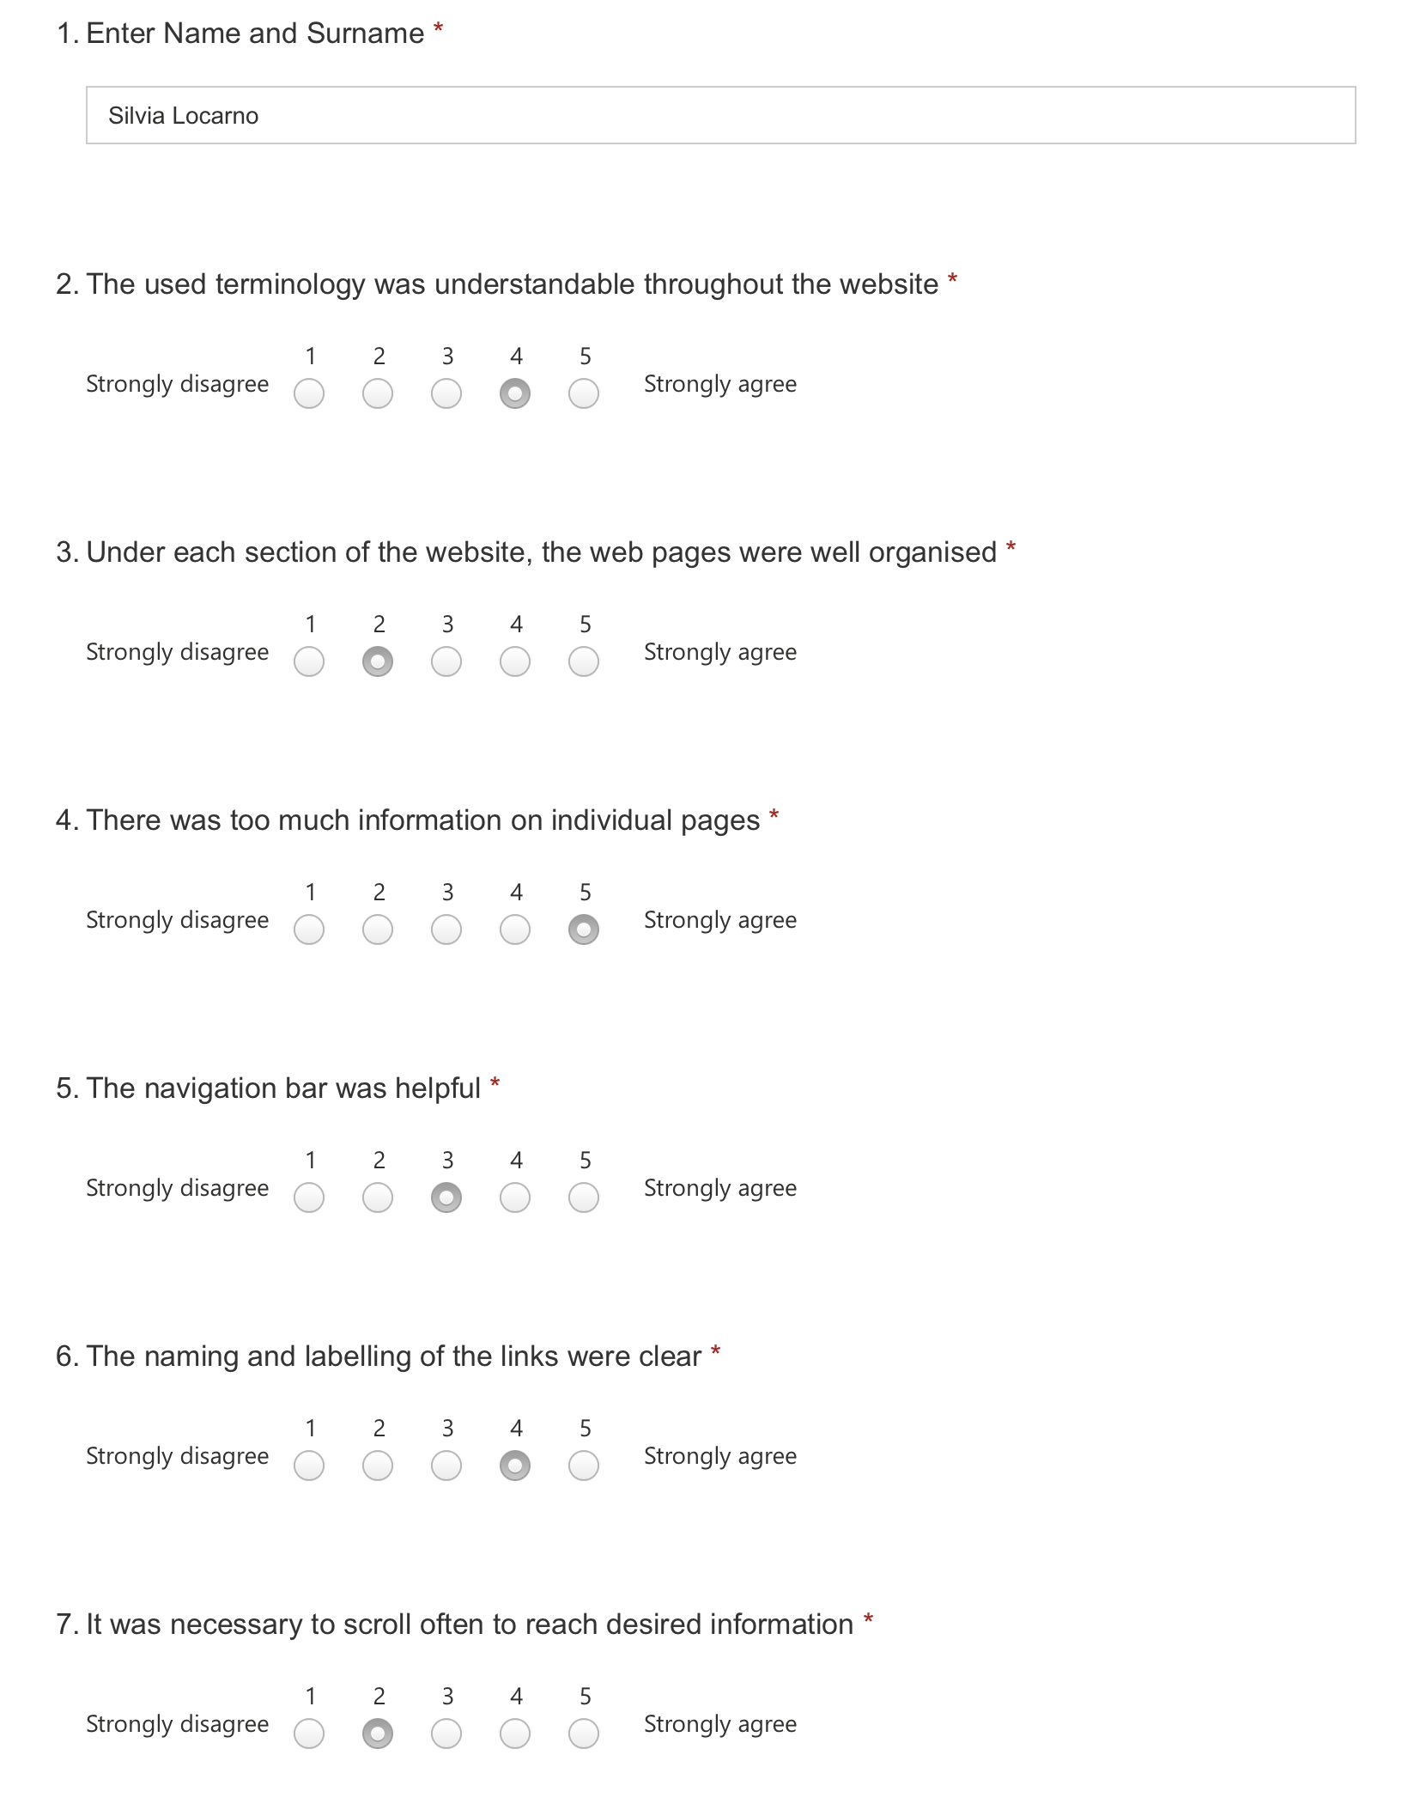

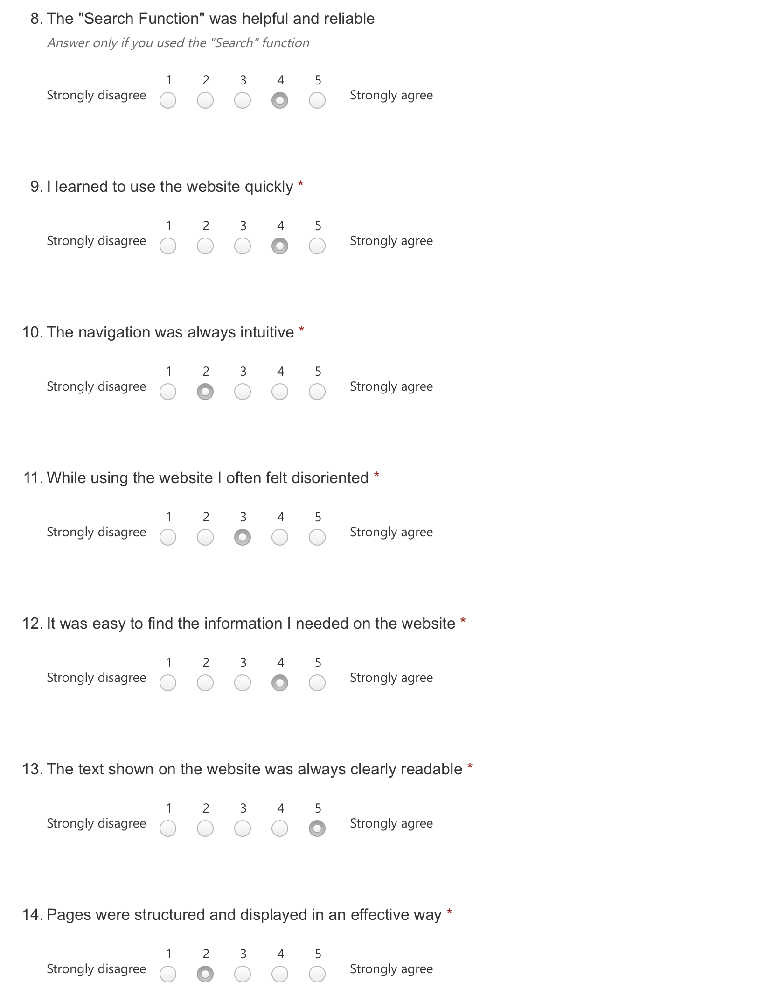

User Testing - User 5

## B.7 User Test 6

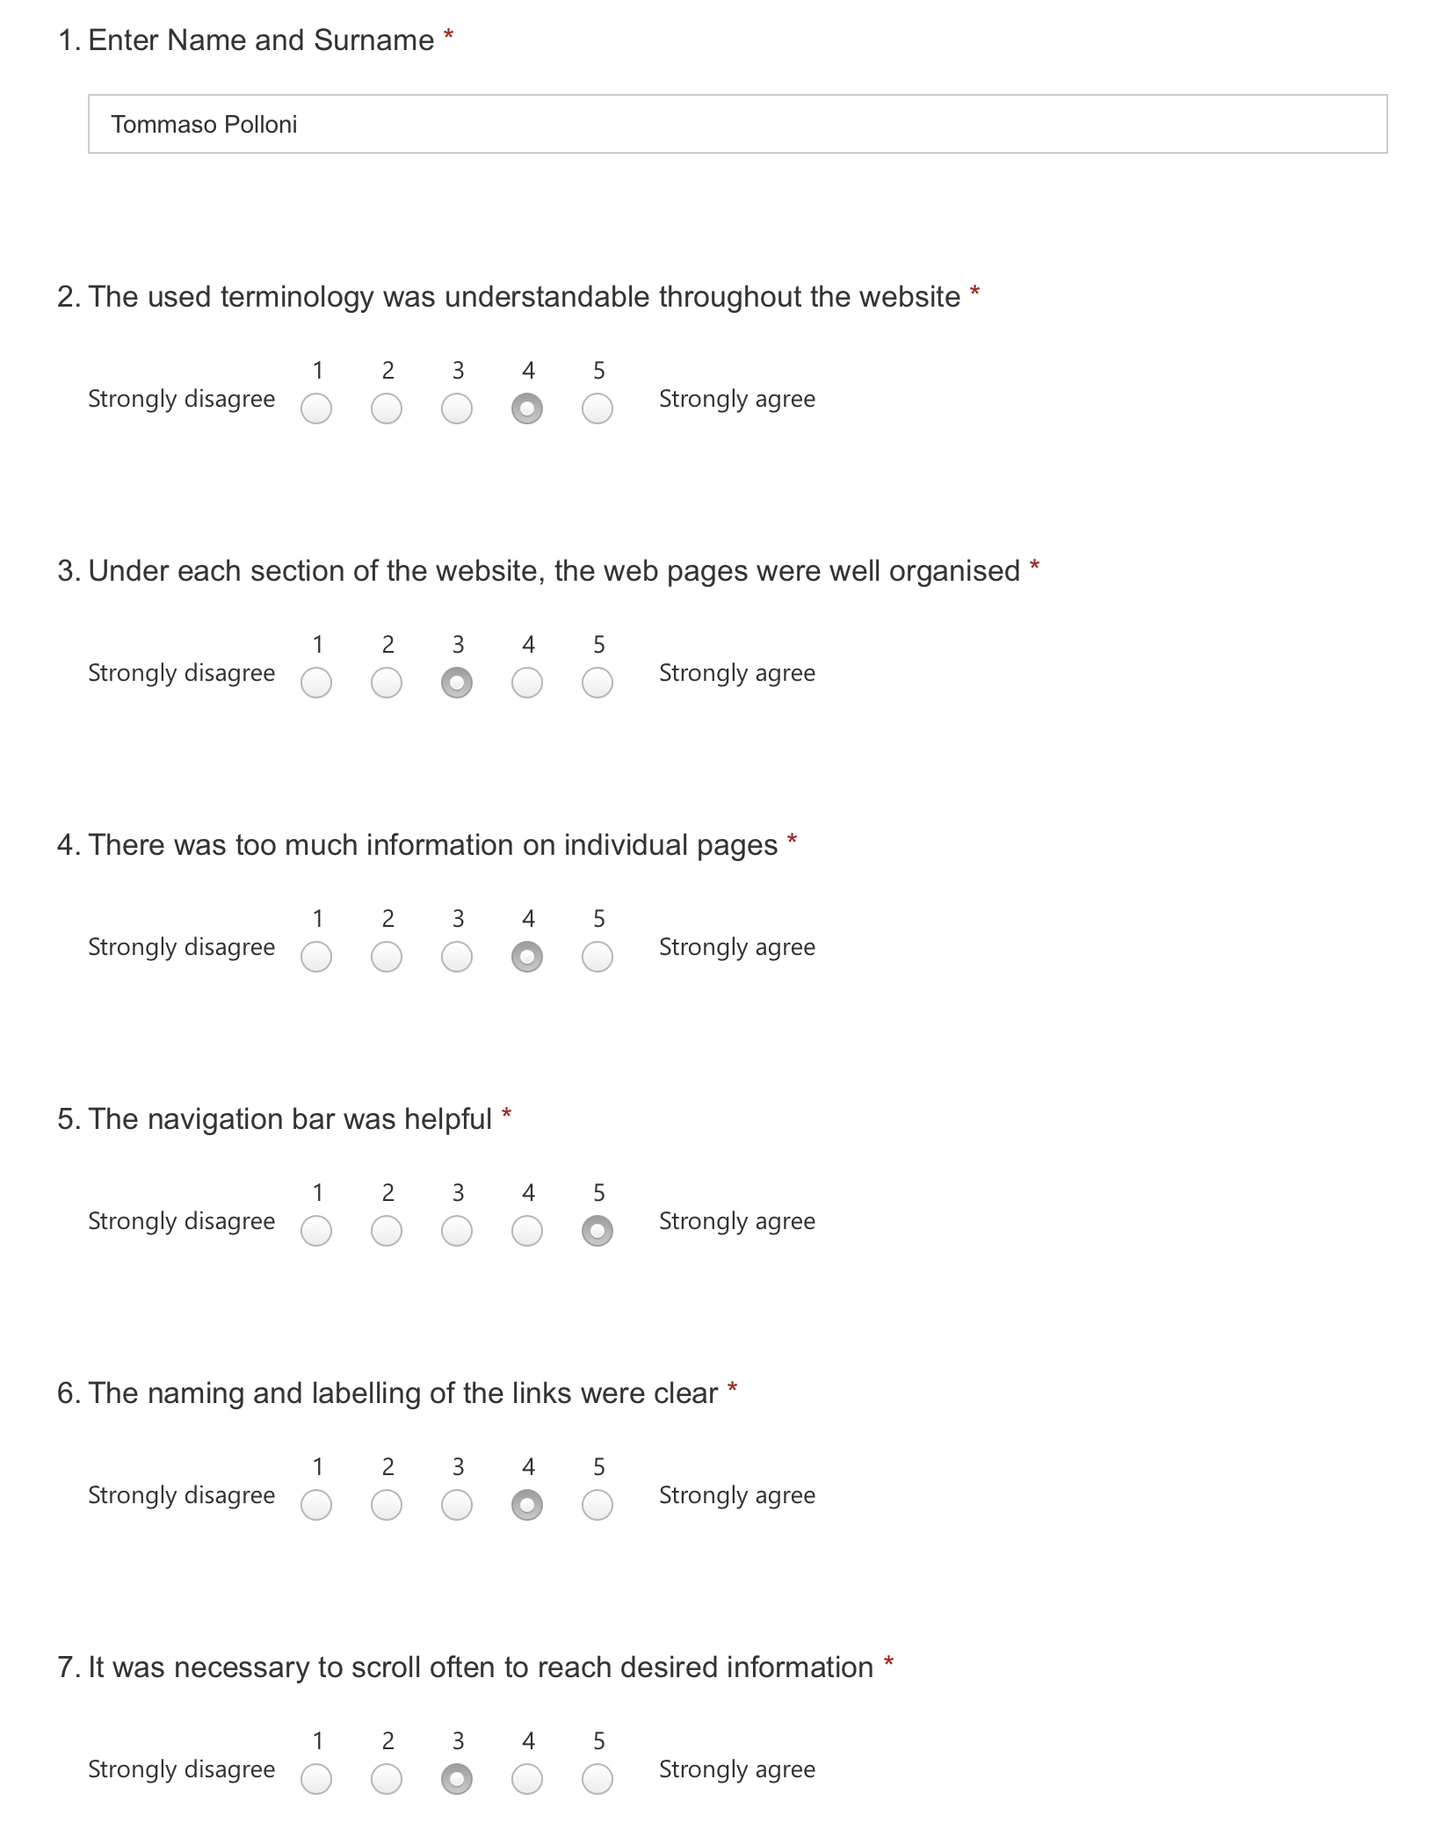

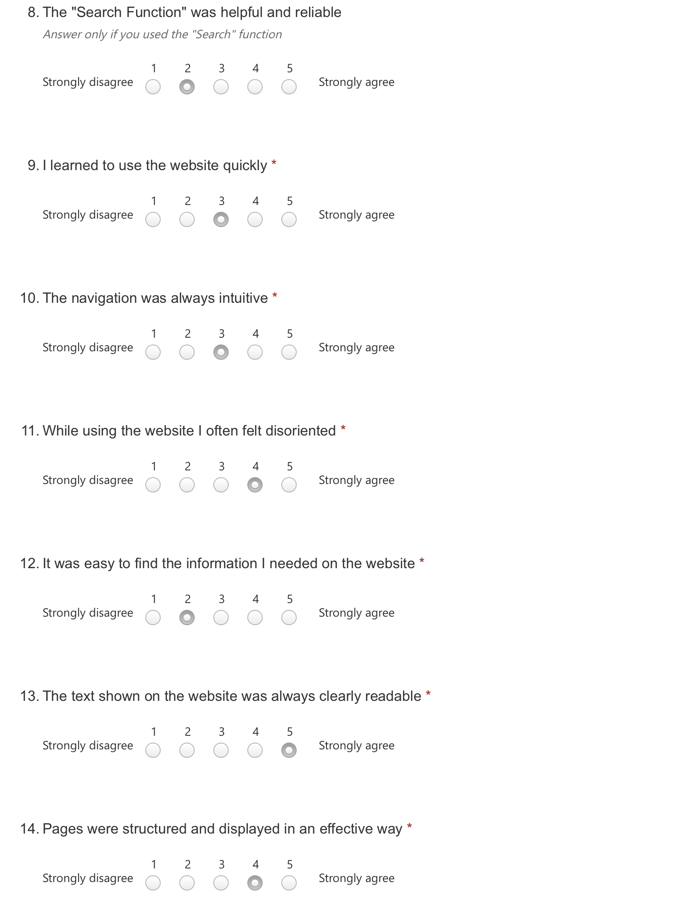

User Testing - User 6

## B.8 User Test 7

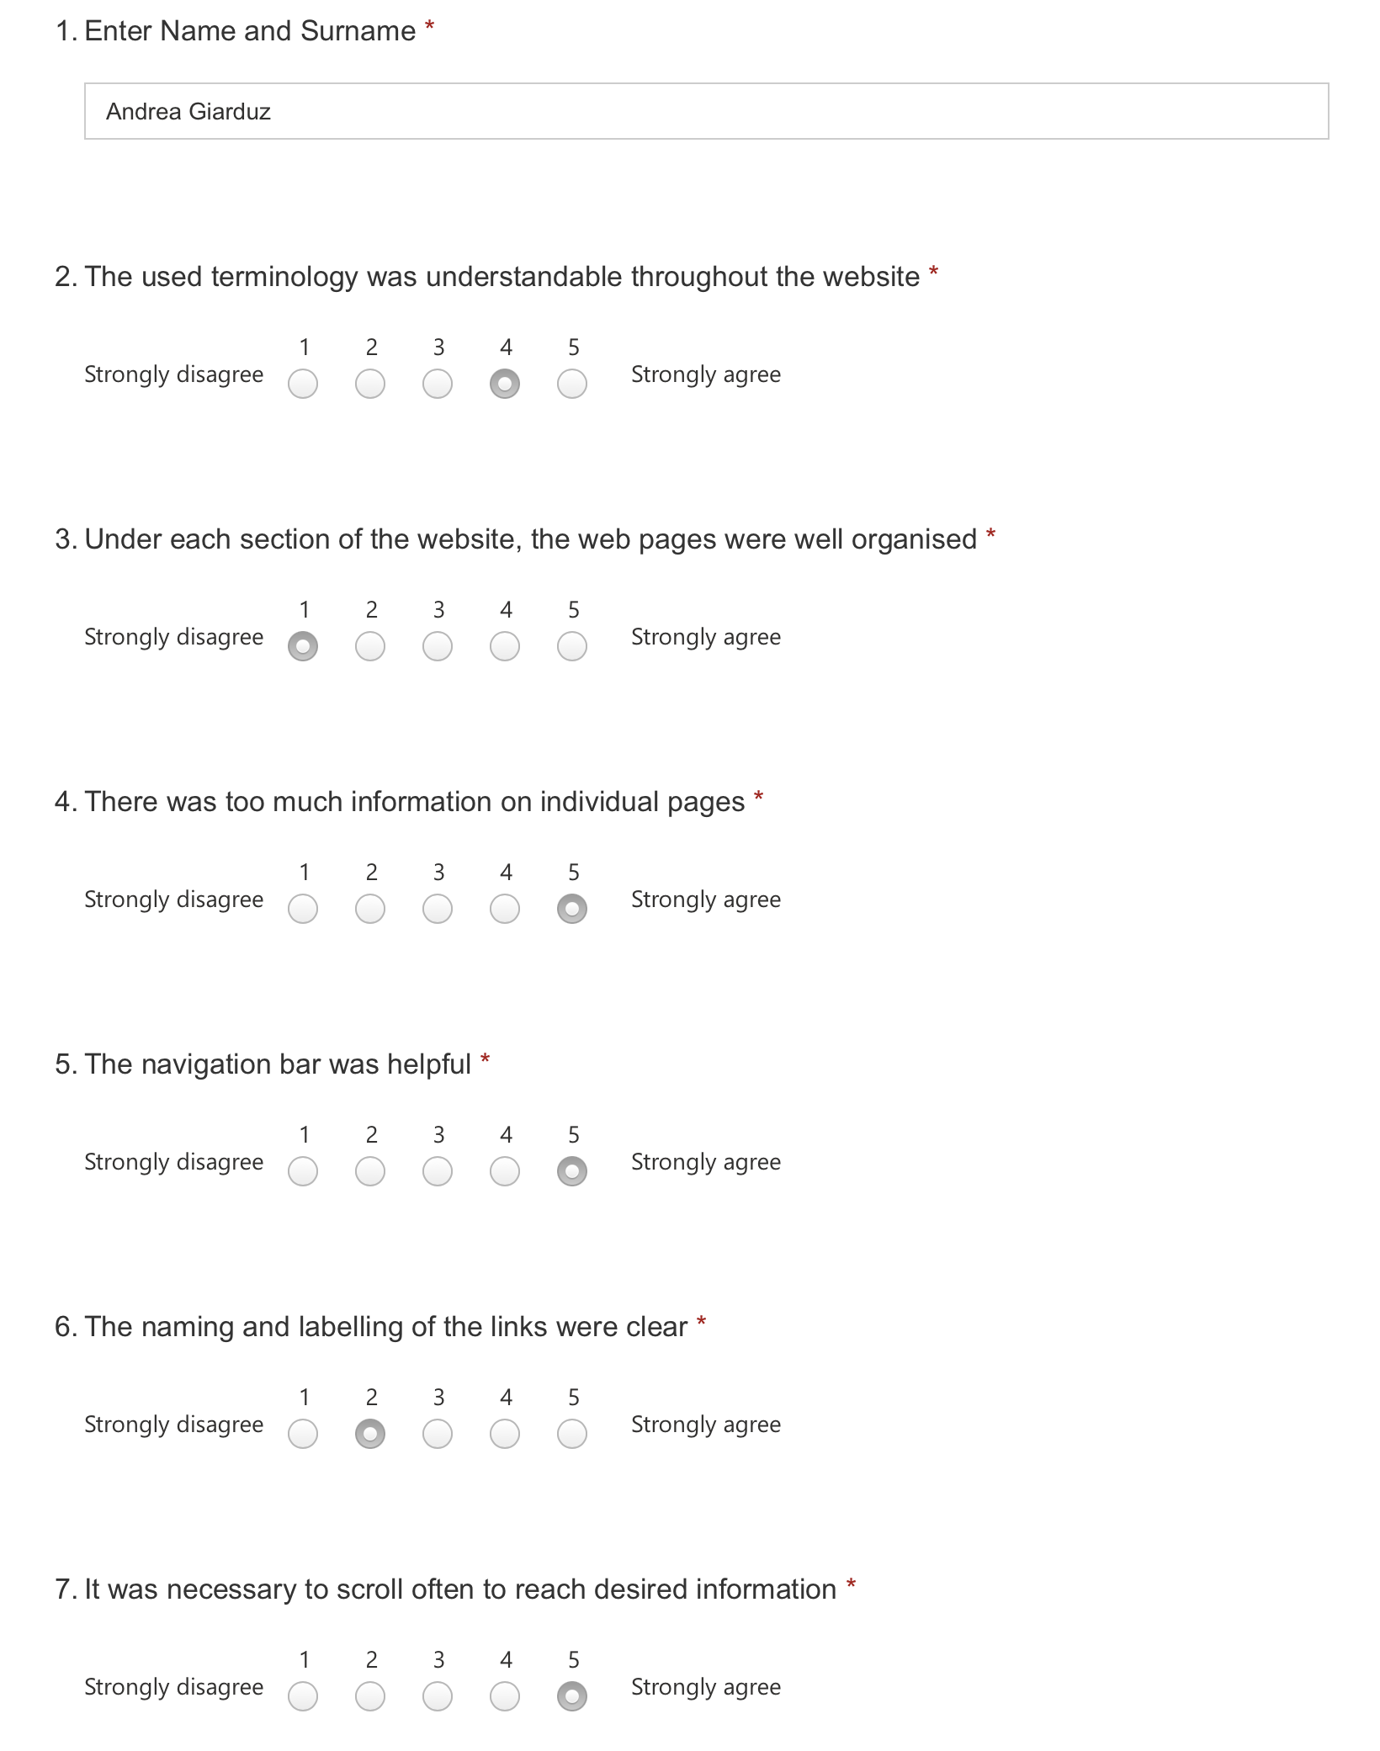

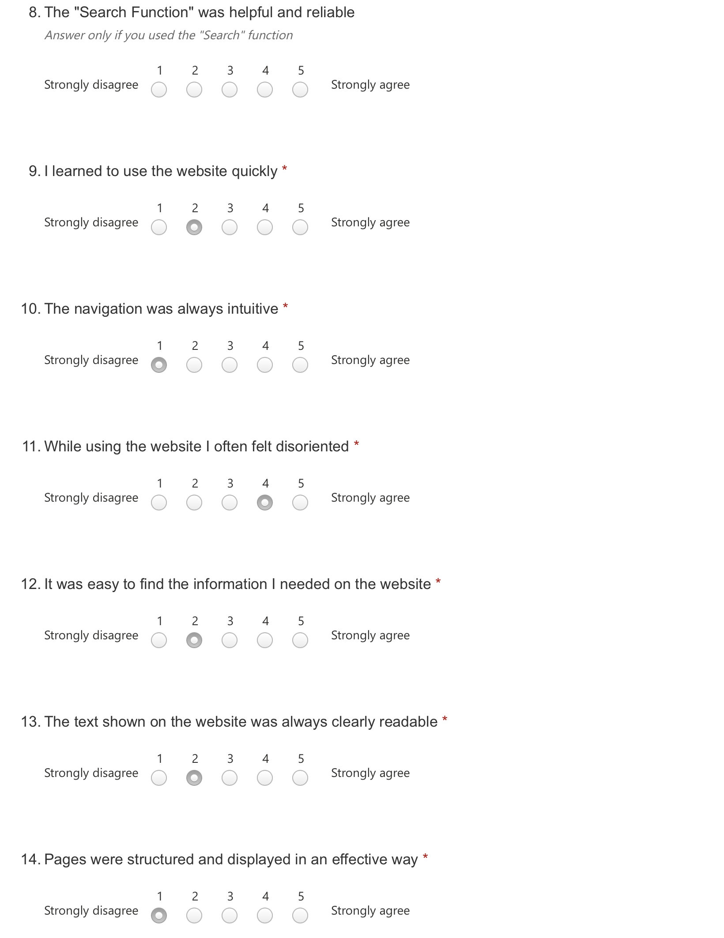

User Testing - User 7

## B.9 User Test 8

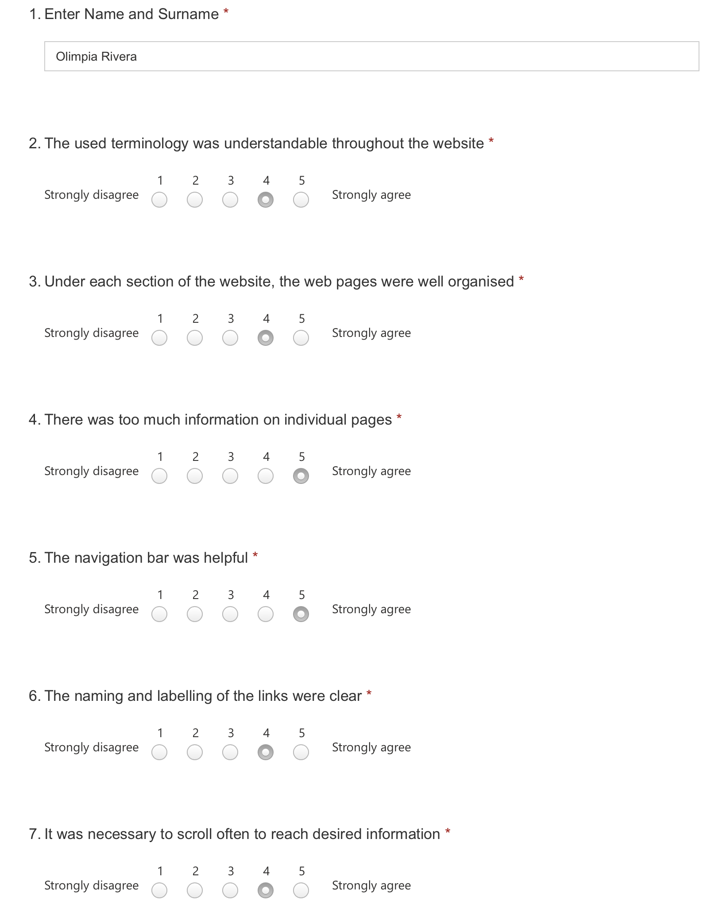

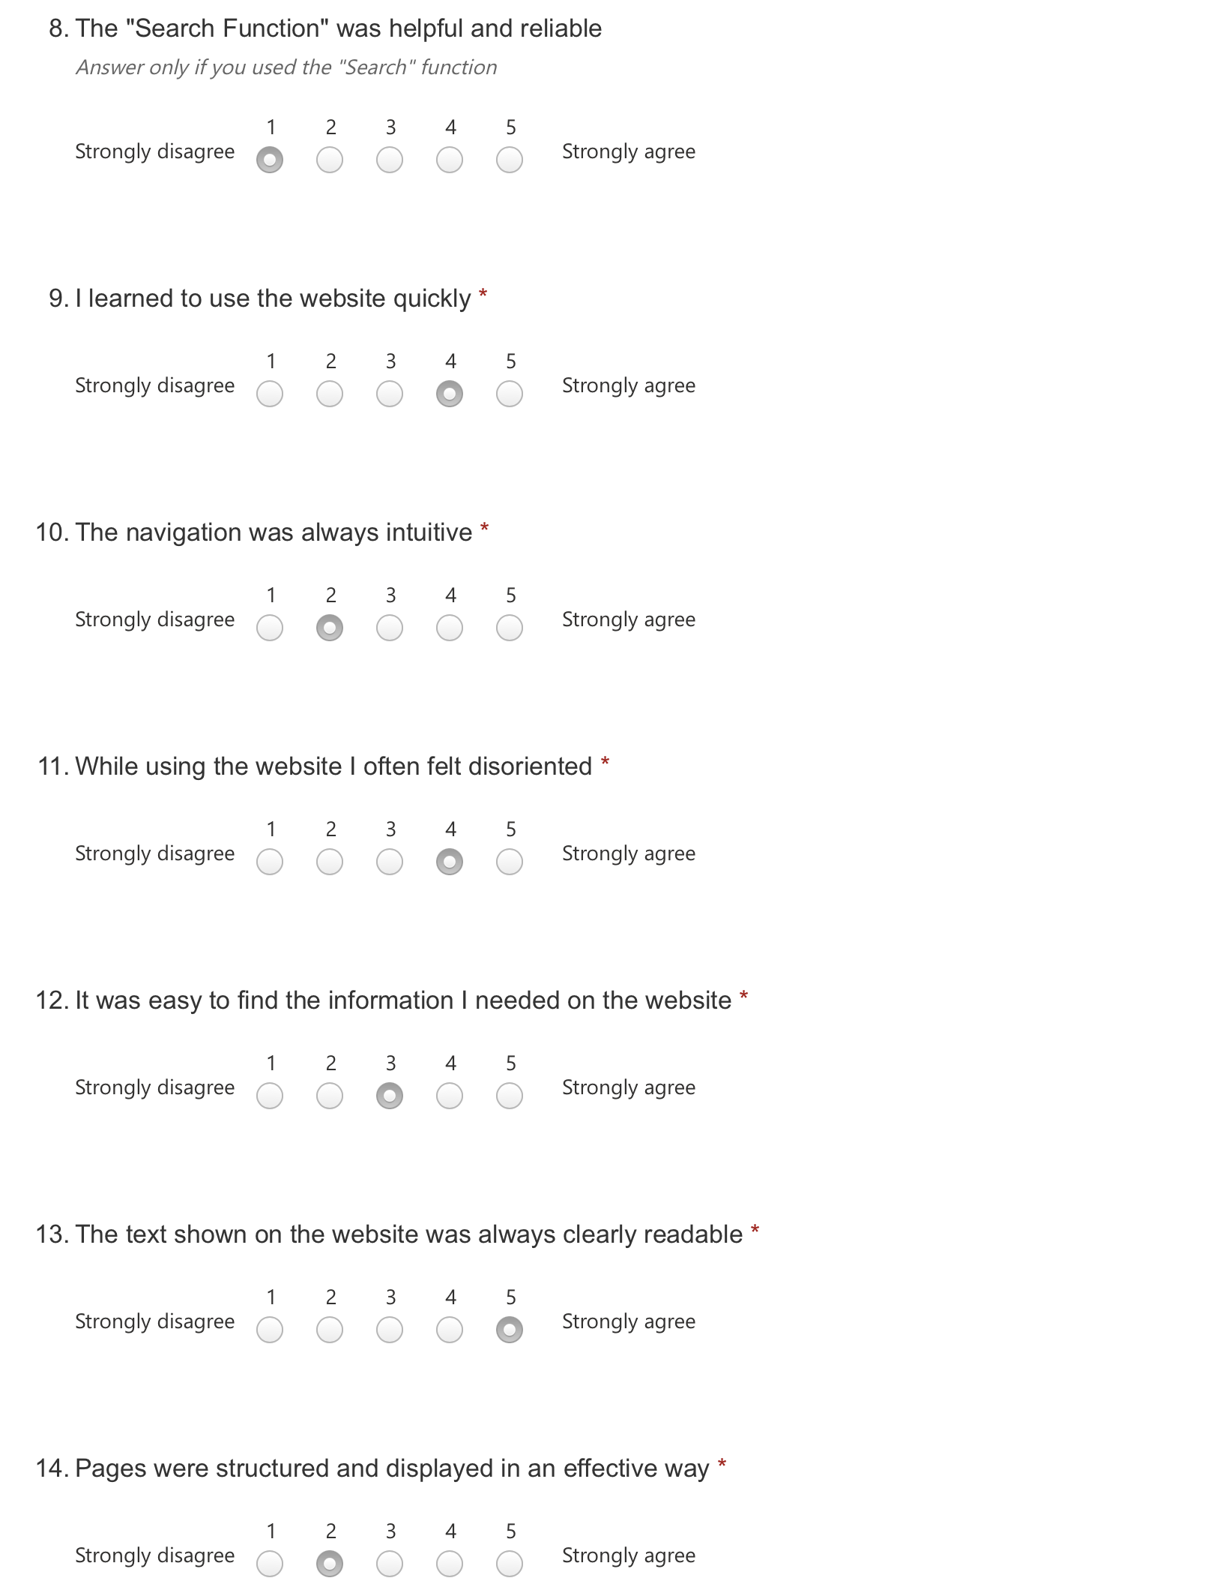

User Testing - User 8